CURRICULUM VITAE
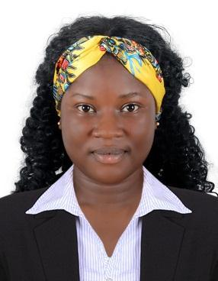

KOMOLAFE

Email id : komolafe.383374@2freemail.com

VISA STATUS : VISIT VISA

OBJECTIVE

To seeking a challenging career by copying a suitable position, utilizing my experience to contribute towards the progress of organization at the same time has the prospect for professional growth and development my career.

WORKING EXPERIENCE:

  - Worked as a “WAITRESS” in REDDISON BLUE FOR 1 YEARS IN LAGOS NIGERIA 2014 - 2015.

- Take restaurant reservations

- Set tables with clean linen or place mats, cutlery, crockery and glasses

- Welcome and seat customers and hand menus to them
- Talk to guests about the menu and drinks and recommend combinations

- In some cases promote local produce and attractions to visitors from interstate and overseas

- Take customers' orders and pass them to kitchen staff or bar attendants
- Serve food and drinks

- Carve meat

- Make up bills and present them to customers
- Handle or Clear tables and return dishes and cutlery to kitchens

  - Worked as a “HOUSE KEEPING” FOR 3 YEARS IN SHARJAH U.A.E 2015 – 2018.

    - Dusting and polishing furniture and fixtures

    - Cleaning and sanitising toilets, showers/bathtubs, countertops, and sinks

    - Maintaining a clean and sanitary kitchen area

    - Making beds and changing linens

    - Washing windows

    - Vacuuming and cleaning carpets and rugs

    - Sweeping/vacuuming, polishing, and mopping hard floors

    - Sorting, washing, loading, and unloading laundry

    - Ironing clothing items

    - Using any cleaning equipment such as vacuums, mops, and other cleaning tools

    - Keeping bathrooms stocked with clean linens, toiletries, and other supplies

    - Cleaning mirrors and other glass surfaces

    - Emptying trash receptacles and disposing of waste

    - Steaming and cleaning draperies

- Washing blinds

- Tidying up rooms

- Monitoring cleaning supplies and ordering more as needed

- Reporting any necessary repairs or replacements

PERSONAL PROFILES:
Nationality | : | Nigeria
Date of Birth | : | 09 may 1991
Gender | : | Female
Marital Status | : | Single
Language Known | : | English, Arabic

EDUCATIONAL QUALIFICATION:

- Higher Secondary Passed (12th Class)

PASSPORT DETAILS:
• | Date Of Issue | : | 31 oct 2014
• | Date Of Expiry | : | 30 oct 2019
• | Place of issue | : | Alausa Lagos

CONCLUSION & DECLARATION:

I hereby certify that the above mentioned Statement is correct & true to the best of my knowledge & belief.

Place : Sharjah KOMOLAFE

