Resume
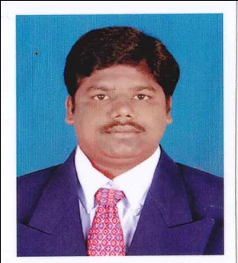

VENKATESAN
Contact No:
E-mail: venkatesan.383380@2freemail.com Total Industrial Experience : 9 Years

OBJECTIVE

To enhance my skill and to obtain expertise in all stages of company development as committed professional and a good team member to achieve excellence by delivering high quality work.

TECHNICAL QUALIFICATION:

Course | Trade | Institute | Board /University | Year of Passing | Percentage of Marks
DME | MECHANICAL | Shreenivasapolytechanic college,  B.pallipatti | DOTE | 2010-2013 | 90%
ITI | Electrician | ARC NatesanIndustrial Training Institute, Mayiladuthurai | NCVT | 2003-2005 | 85%

EDUCATIONAL QUALIFICATION:

Qualification | Institute | Board /University | Year of passing | Percentage of Marks
S.S.L.C. | Govt.Hr.Sec.SchoolNannilam, Tiruvarur Dt. | State Board | 2003 | 60%

Additional Qualification:
- AUTOCAD

Computer Skills:
- Micro Soft office (Excel, Word and Power Point

Project details:
- Fabrication of solar based on Photo voltaic cell

Working in Experience

Name of the Company : Sahab Al Sharqiah Contracting Co. Saudi Arabia.
Nature of Production : Asphalt & Building Construction
Position : Store Keeper for Mechanical Spares
Duties & Responsibilities : All automobiles spare parts names and uses known to Arabic
laungauge. Learned Arabic letters and numbers.
Period : 15 Month.

Name of the Company : Modular Auto Ltd Ambattur Industrial Estate
Chennai-53.
Nature of Production : Production for Wheel Cylinders
Position : Production Operator / Machine Setter
Knowledge of Machine : Operating and setting up the following machines Tarrus, CNC,
Turning, Chuckmatic, Wyvomatic, VMC, Gildmeister and
HMT fine boring machine.
Period : 1 Years

Name of the Company : TVS BRAKES INDIA LTD, POLAMPAKKAM,
CHENNAI
Nature of Production : Caliper Brakes & Drum Brakes
Position : Quality Assurance Line and Final Inspector
Duties & Responsibilities : Line and final Inspection of caliper brakes, ‘’S’’ cam brakes,
lined shoeassembly based on blueprint drawing. Conducted
assembly test at assembly shop including Housing, Carrier,
Piston and Sub assembly parts.
Period : 1years

Name of the Company : Sri Balaji Castings Pvt Ltd, Ambattur Chennai-53
Nature of Production :Axle Arm Production
Position : Quality Controller Shift in charge.
Duties & Responsibilities : Inspect the axle arm by using Vernier Caliper, Height Gauge,
Micrometer, Comparator, dialIndicator, Bevel Protector, Plug
gauge and Thread Plug gauge.
Period : 6Years
PERSONAL DETAILS:
Date of Birth : 07.05.1988
Visa status : visit visa
Nationality : Indian
Languages Known : Tamil, English and Arabic

DECLARATION:

I hereby declare that the information furnished above are true and correct to the best of my knowledge.
Thanking you

