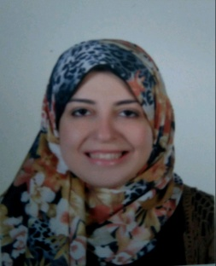
CV
Mai
Date of Birth: 25/08/1986 Nationality: Egyptian
Email Address: mai.383391@2freemail.com
Marital status: Married.

My Objective:

Secure a position with a leading organization that will lead to a long term career relationship.

Academic:

2004- 2008:
Graduation University: Al Azhar University.
College: Faculty of Humanities studies- Spanish Dept.
Degree: Bachelor.
Graduation Degree: very good
Graduation Year: 2008.
High School:
Al- Azhar Institute

Languages:
Mother Tongue: Arabic.
Foreign Language: English. (Very good written & spoken).
Spanish (good written & spoken).

Computer skills & courses:
- International Computer Driving License. (ICDL)
- English courses in MODL
Note: Interest and ability to learn new software programs.
At work:

From 3/6/2012
till 11/2016:
- Worked in Style for Ceramic & porcelain Industry as Executive Secretary
The field of Executive Secretary:
- Provide administrative and clerical support to departments or individuals.
- Schedule meetings, prepare agenda for meetings & take notes. Arrange conference rooms. Alert managers about cancellations or new meetings. Coordinate office management activities.
- Handle information requests. Receive and relay telephone messages.
- Prepare correspondence and stuff mail into envelopes. Arrange for outgoing mail and packages to be picked up.
- Greet and receive visitor.
- Prepare confidential and sensitive documents.
- Determine matters of top priority and handle accordingly.
- Helps prepare office budget.
- Plan for important events and internal and external Exhibition.
- Coordinate travel arrangements; prepares itineraries; prepares, compiles and maintains travel vouchers and records.
- Relay directives, instructions and assignment to executives.
- Direct the general public to the appropriate staff member.
- Maintain hard copy and electronic filing system.
- Sign for UPS/Fed Ex/Airborne packages.
From 1/6/2011
till 1/6/2012:
- Worked in Zaitia Authorized Distributor Industrial Oil Co. as The Company Secretary

From 5/8/2008
till 1/9/2010:
- Worked in Smart Group for Internet & network Solutions in different departments as (an agent in collection dept. + a web design coordinator & finally in Customer account as a data entry for the requests of clients by the websites of Te Data & Link DSL.

What do I do in my spare time?

- I like travelling with family & friends, watching TV. , making accessories, sewing, walking & cooking.

References are available on request.

Thanks for your time

