CURRICULUM VITAE

Sales Executiveand Business development Professional

Recognized for high professional merit & excellence in the entire career

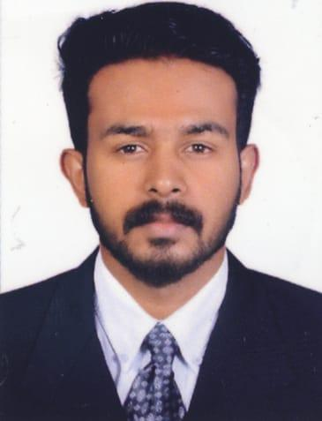
SHAMEEMUL
E-mail: shameem.383404@2freemail.com
OBJECTIVE
To obtain a challenging position in forward companies for utilizing my skills and abilities that offers professional growth while being resourceful, innovative and flexible. I want to be creative, learning and contributing towards the success of the company,

EXECUTIVE PROFILE

- 4 year experience for the excellent electrical trading company pvt.lmt
- 1 years’ experience for the baith al manthi restaurant
- 1 year experience for ace academy science institution
- Postgraduate Islamic finance
- degree graduation computer application
- Data entry (English and Arabic)
- Excellent communication skill
- Computer skill

EXPERIENCE SUMMARY

- Excellent electrical tradingcompany PVT, LTD|Sales Executive: Business developmentKerala region| January 2012 to Oct 2015

- Baithalmanthirestaurant: India | Cashier and Receptionist|April 2015 to Oct 2016
- Ace Academy science institution: India|Receptionist and office administration|December 2017 to July 2018

Positives

- Sincere and straight forward
- Hard worker
- Self-motivated

Adaptability
- Pleasing personality
- Innovative

EDUCATION & PROFESSIONAL DEVELOPMENT

- Post-graduation in MASRTER OF ISLAMIC FINANCE, (Specialized in Islamic Banking and Economics) University of Calicut, Kerala.
- Graduated in BACHELOR OF COMPUTER APPLICATION (BCA), University of Calicut, India
- HIGHER SECONDARY, Board of Kerala Govt., India
- SECONDARY, Board of Kerala Govt., India

PROJECTS

- A Project completed on the basis of M.A Islamic Finance syllabus titled as “INTEREST FREE FINANCE AS A ALTERNATIVE FOR AGRICULTURAL FINANCE IN INDIA:- CASE OF SALAM CONTRACT”
- A study on problems of agricultural finance in India (PG)
- A study on interest free economy (PG)
- Project on student registration application (BCA)

ITSKILLS

- Microsoft Office - Word, Excel, PowerPoint
- Browsers: Chrome, Safari, Firefox, Opera
- Good typing speed
- Hardware: PC’s, Laptops, Telephones, Printers, Tabs, Scanners
- Internet Operation

OTHER PARTICULARS

- Date of Birth: 25-05-1994
- Nationality: Indian
- Religion: Islam
- Languages : English, Hindi, Malayalam

DECLARATION

I hereby do declare that the above information’s are true, complete and correct to the best of my knowledge and belief.

