CURRICULUM VITAE
ABDUL
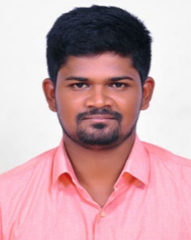
CAREER OBJECTIVE
Email: abdul.383411@2freemail.com

To seek a challenging position in a reputed organization that gives me challenges and opportunities to enhance my knowledge and hone my skills in accordance with latest trends and part of a team that dynamically work towards the growth of the organization.
EDUCATIONAL CREDENTIALS
- Bachelor of Engineering (B.E.) in Mechanical Engineering
From Anna University, India (2012 – 2016)
- Nebosh Award in Health and Safety at Work
From Nist Institute Private Limited, India (March-2018)

AREA OF EXPERTISE
- Quality Assurance & Inspection.

PROFESSIONAL EXPERIENCE
- Worked as a Quality Inspector- Ucal Fuel System Limited, Chennai, India.
UCAL FUEL SYSTEM LIMITED (NOV’2017 – DEC’2018)
JOB RESPONSIBILITIES

- Assuring and Controlling Quality of Machining Components.
- Reporting and Monitoring Daily Inspection Checklist by Walk around Inspections.
- Patrol Inspection & Gauge Checking Inspection. If Component are Non-Conforming to Specification move the Components to NCC (non-conforming components) area with Rejection tag if Components are accepted fill the Tracer Tag and move the Components to next process.
- HandlingMeasuring Equipment’s likeVernier Caliper, Micrometer,Profile Projector, Dial Gauges, Special Gauges, CMM, Basic knowledge about GD&T.
- Coordinating all activities and maintaining 5S &7QC Tools.
- Involvement in New Product development and Setup Approval.

TECHNICAL PROFICIENCY
- Certification in CMM (Coordinate Measuring Machine)& ITS APPLICATION.

SOFTWARE PROFICIENCY
- Certification in MS OFFICE & INTERNET.
- Certification in UNIX & C.
PERSONAL DETAILS
- Date of Birth | : 23-03-1995
- Gender & Marital Status | : Male & Single
- Nationality | : Indian
- Religion | : Islam
- Mother Tongue | : Tamil
- Languages Known | : English, Tamil
DECLARATION
I hereby declare that all the above furnished details are true to the best of my knowledge and belief.

