CURRICULUM VITAE
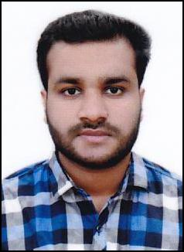

SUSHIL

Email: sushil.383412@2freemail.com

CAREER OBJECTIVE

Aspiring for suitable job to establish my growth in creative environment in which I can use my skills and hard work to prove myself.

EDUCATIONAL QUALIFICATION

- S.S.L.C

- HIGHER SECONDARY

COMPUTER QUALIFICATION

- Basic Knowledge

EXPERIENCE

- Worked as Sales Man in Lulu Hypermarket (Grocery food and non-food) Oman for 2 years.

- 1 year Experience Van Sale IN P&G Sabari Distribution Kannur.

- 2 years experience Sales executive in Gadre Marine Exports Pvt Ltd Kannur,Kearala

PERSONAL DETAILS
Date of Birth | : | 26th December 1993
Religion | : | Hindu
Gender | : | Male
Marital Status | : | Single
Nationality | : | Indian
Languages | : | English, Tamil, Hindi, Arabic, Malayalam
PASSPORT DETAILS
Date of issue | : | 11/02/2015
Date of expiry | : | 10/02/2025
Place of issue | : | Kozhikode

DECLARATION

I hereby declare that the above information are true and correct to the best of my knowledge and

belief.

