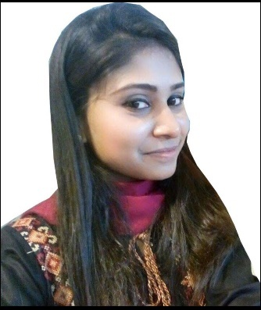  EDUCATION  2013-2017  2013  2008  WORK EXPERIENCE  INTERNSHIP  CERTIFICATES  LANGUAGES  UNIVERSITYPROJECTS  Khadim Ali Shah Bukhari Institute of Technology  SKILLS  PERSONAL PROFILE | SANIYA  Email: saniya.383422@2freemail.com  Looking for a challenging and stimulating environment where I envisage career development that provides an ambiance for learning and professional growth.  MBA-MARKETING  - Khadim Ali Shah Bukhari Institute of Technology (KASBIT)  B.COM  - University Of Karachi  I.com  - Board of Intermediate Education Karachi  - April 2016 to March 2018  - FAYSAL BANK LTD  - Relationship Manager  - Oct 2015- Jan 2016  - BANK ALFALAH LTD  - Internee  - June 2015-Aug 2015  - Together Consultancy  - Internee  - Trainee Relationship Manager  - Oracle (uncertified) as job priority  - On job trainee certificate  - Microsoft Office  - English & Hindi  - Led a group responsibility on a project of marketing management & research.  - Performed an economic survey in a city & analysis market fluctuation according to the price.  - Designed a management report &their objective, strategies, policies etc of a company.  - Also worked as a creative head in a seminar of PAK CHINA friendship.  - Presented as a speaker in a seminar of Pakistan’s problem & their solution.  - Have a thoroughly an analysis on the working of FMCG business in Pakistan.  - Performed as a volunteer in a CSR activity for the Thales mea patients.  - Prepared an advertisement of crockery in a Brand management project  - Good Commands in Microsoft Office  - Average typing speed  - Internet browsing  - Positive and non-aggressive when faced with conflict  - A good Team player and Leader  - Time Management  - Enthusiastic Team player, motivate others in the team  - Quick Learner with Adaptable Attitude  - Familiar with Microsoft Office Tools  Date of Birth: 13TH OCT,1991  Nationality: Pakistani.  Religion: Islam  Marital Status: Married

