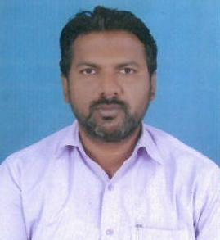
CURRICULUM VITAE

FAHEEM

Email Id : faheem.383429@2freemail.com

Dubai U.A.E

Post Applied For: Catering Supervisor / Events Supervisor

Objective:

To look for a suitable position in a progressive organization, where I can use my abilities and hard work towards the achievement of company objectives. I can assume any kind of challenging assignment and try to accomplish it with serious effort, competence and honesty.
Educational Qualifications:

- SSC

- Plus Two

Languages Known :

- English, Hind and Telugu
Personal skills

  - Strong interpersonal & communication skills

  - Very good team managing skills & team working

  - Able to work under pressure & meet deadlines

  - Hardworking, efficient, proficient, deal effectively with conflicts

Work Experience:

- Worked as a ​Catering Supervisor at ​S.V Events Management Pvt Ltd in India, Hyderabad​for ​18 Years​.

Job Descripptions:

- Handle Employee Issues and Training. Catering Supervisors interview, hire, train and manage employees. ...

- Provide Customer Service. ...

- Plan Menus and Order Supplies. ...

- Ensure Compliance with Regulations. ...

- On the Web. ...

- Industry Groups​....

- Catering Supervisor Books.

Personal Profile

Nationality | : | India
Date of Birth | : | 18/04/1983
Marital Status | : | Married
Religion | : | Muslim
Visa status | : | Visit

Declaration:

I hereby declare that all the details mentioned above are true and benefited to the best of my knowledge and belief​.​I hope the above details will meet with your requirements and you will give due consideration to me.

FAHEEM

