OPANY
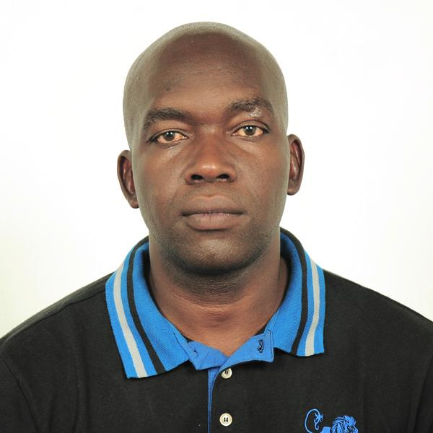
CURRICULUM VITAE
PERSONAL PROFILE:
NATIONALITY: KENYAN
DATE OF BIRTH : 08/11/1976
MARITAL STATUS / CHILDREN : MARRIED WITH ONE SON
EMAIL: opany.383458@2freemail.com

- Decisive, Adaptable, gender and culturally sensitive, result-oriented, disciplined team player, energetic, self motivated, creative and dedicated individual with an eye for detail. Have a good academic background along with a broad entry level experience in Sports Sciences – Physical Education and possessing skills and offers outstanding talents and ability to co-operate with all. Driven by new challenges and desires to be successful in all endeavors. Excellent interpersonal skills, able to work under pressure with minimum supervision. Good researcher.

CAREER OBJECTIVE:
- To work for a leading institutions /organization that encourages growth in a position that gives me a sense of responsibility and utilizes my skills fully in achieving the firm’s objective.
SKILLS AND EXPERIENCE
- Team player with good communication skills and able work under pressure.
- Trained and confident.
- Knowledge of methods of Teaching and Coaching.
- Knowledge of philosophy and practice of sports education.
- Ability to teach , train ,coach and officiate various sports at Primary, Secondary ,Tertiary University ,Military /Police Force colleges – National and International level.
- Ability to Co-ordinate / Manage various Sporting Activities/Meets.
- Knowledge of management and Guidance & Counseling.

EDUCATION AND QUALIFICATIONS
- Bachelor of Science Honors’ Degree in Sports Science & Coaching- Zimbabwe Bulawayo
April 2012-November 2015
- Level 3 IVQ Advanced Diploma in Teaching, Training, Assessment and Learning Skills- City and Guilds UK. June 2008-July2010
- Bachelor of Arts Degree (Physical Education) KenyattaUniversity July 2006-July 2009
- Diploma in Management of Olympic Sports Organizations- IOC –Kenya November 2006
- Certificate Early Childhood education- Ministry of Education Kisumu -Kenya April 2001
- Certificate Psychological Counseling, Institute of professional Counseling Kenya June 2001
- Kenya Certificate of Secondary Education – Ramba High school – Kenya 1991-1994
- Kenya Certificate of Primary Education – Kibuye Primary School- Kenya 1982-1990
OTHER CERTIFIED COURSES COMPLETED
- Certificate Life Saving Course-FINA/KRC/BSC/IOC-Mombasa-Kenya :2017
- Certificate Swim South Africa Officials/Referee Instructors Course- Botswana :2015
- Certificate Handball Coaching/Training/Umpiring Course – Gaborone-Botswana :2015
- Certificate Swim South Africa Officials, Referee, Instructor’s Course- South Africa :2013
- Certificate Net Care First Aid level One, Two, Three –Pretoria – South Africa :2013
Certificate Cricket Coaching Training - ICC - Gaborone – Botswana. :2012
- Certificate MRI heart saver certificate – Gaborone – Botswana. :2012
- Certificate lifesaving course - Kenya December :2009
- Certificate Life Saving Course-FINA/KRC/BSC/IOC-Nairobi-Kenya. :2009
- Certificate Volleyball Umpiring/Coaching Clinic- Otse Police College- Botswana. :2008
- Sports InjuryManagement First Aid-Charity Research Training&Consultancy(SA) May: 2007
- Certificate Officials/Officiating Course –BSSA Gaborone – Botswana. :2007
- Certificate Softball Umpiring Coaching Course-Gaborone – Botswana. :2006
- CertificateAfhf Whup- Umpiring/Coaching (Hockey) Botswana - :August 2006
- Health Science- Nelson Mandela MetreoP University :December 2005
- Sports Trauma Management – Faculty of Health Science- Univesity of Pretoria :December 2004
- Certificate Cricket Coaching /Umpiring Course- SCA-Pretoria- SA :July 2003
- Certificate Refreshers Course P.E by Ministry of Education Nakuru - Kenya :Feb 2003
- Certificate Athletics Course, IAAF/KAAF/IOC-Nairobi- Kenya :Dec 2002
- Certificate Business Management- Kenya Institute of Management :Sept 2002
- Certificate Hockey Coaching / Umpiring Kampala – IOC Uganda :Dec 2001
- Certificate Coaching/Officiating Tennis; KTA/WTA/ITF-Kisumu -Kenya :July 2001
- Certificate Coaching/Officiating (Baseball/Softball) Nairobi-Kenya :Sept 1998
- Certificate Provincial Secondary Schools Coaching/Refereeing Course. :July 1998
- Certificate World Soccer Development Clinic/Fifa /Olympic Solidarity Course :Aug 1996
OTHER WORK EXPERIENCE.
-HIV and AIDS Control Centre Botswana-Testing, Guidance and Counseling- part time - 2009-2010
-Hockey Head Coach Kisumu Simba club - Africa Club Cup Championship Pretoria -South Africa - 2003
-Oasis Academy Assistance Sports P.E teacher /Coach. - 2001 – 2002
-Makerere University-Attached to Sports Department: Head Coach for East, West and Central Africa Inter University Games Kampala- Uganda. October 2001 to December 2001

WORK EXPERIENCE.
HOD Sports/PE Coordinator, Guidance Counseling Rainbow Schools 2012 to 2017 DEECEMBER
- Conducting PE Lessons from STD 1-7, and Form Ones (1) to form Fours (4) IGCSE.
- Sports Coordinator/Administrator and Extra-Curricular Activities(Sponsored walks/sport days/prize giving, hosting various sporting activities (Tournament ball sports galas, meets Athletics- (field & track), and cross county.)
- Coaching /umpiring /Training students all sports in the Private School Sports Calendar.
- Organizing and Administer Sporting Fixtures/Meets.
- Deputy Chair Disciplinary Committee.
- Committee member - Rainbow Welfare, TLC, Staff functions/Events.
- Rainbow School First Aider, Transport Manager /Coordinator /Trips/Tours.
- Treasurer, Cricket, Hockey, Athletics and Softball Code Chairperson- CHIPS /ISSA Schools.

HOD Sports/ PE, Guidance & Counseling - Legae Academy School-Botswana, -2009-2011
- Conducting PE/Guidance & counseling lessons form 1- 5 and afternoon activities. IGCSE
- Co-coordinating /Administrating sports and extra curricular activities(Sponsored walk/sports day)
- Coaching /Umpiring /Training/Assessing students in all sports in the Independent Secondary school sports calendar, fixtures,
- Conducting lectures in Anatomy, Physiology, Biomechanics, Kinesiology and Sports Medicine
- Setting and Making Examination and Assessment (theory and practical) PE/SPORTS
- School First Aider.
- Committee member - Rainbow Welfare, TLC, Staff functions/Events.
- Conducting sports Programme and Facilitating clinics. (Hockey code chair person)
- Class teacher form 2 and 3.
- Facilitator(Botswana hockey association)coaching/training /umpiring clinic
Sports PE, Counseling Teacher- Legae Primary School-Botswana- Jan 2004-May 2006.
- Conducting PE Lessons from STD 1-7. Cambridge syllabus
- Co-coordinating /Administrating sports and extra curricular activities(Sponsored walk/sports day/prize giving, hosting various sporting activities(tournaments, ball sports ,galas, meets and cross county)
- Coaching / umpiring /Training students all sports in the Private School sports Calendar.
- Organizing and administer sporting fixtures.
- School First Aider.
- Committee member - Rainbow Welfare, TLC, Staff functions/Events.
- Hockey code chair. ISSA
- Class teacher Std 6.
- Head of MaintenanceLegae school offices, classrooms, grounds, pools and staff houses.

Sports Development Officer Botswana National Sports Council- 2003-2004.
- Co-ordinate tertiary sports, zonal and national level.
- Introduce and Develop Hockey and other Sports in Schools,Institutions (Private and Public) UB, Botswana Police/Botswana Defense Force, Teachers Colleges, Clubs and to Develop Players.
- Conducting,Organizing,Coordinating,Development clinics{Coaching/Umpiring/Training clinics}
- Prepare and select the national teams(juniors and under 21s)
- Designated coach and manager to touring teams local, zonal, national and international.
- Organize and assist in execution of junior sporting leagues/fixtures/games.
- Guidance and counseling, Abstinence.
- Botswana Hockey Association – Umpire/Coach/Trainer

EXTRA CURRICULUM ACTIVITIES.
Meeting people, reading, enjoy watching, playing, coaching umpiring, training sports and fitness/health training.

COMPUTER QUALIFICATIONS / KNOWLEDGE

I possess hands on knowledge in the following;
- Diploma in Computer studies
- Operating and Application software
- Microsoft Office Suite[Word, Excel, PowerPoint, Publisher, Database, Spreadsheet One/Out note, Outlook]
- Internet Intranet, Extranet, browser [Internet explorer/Firefox]
- Information Networks.

