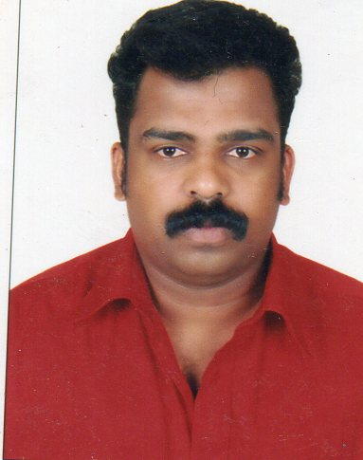
CURRICULUM VITAE
RATHEESH

EMAIL- ratheesh.383487@2freemail.com
------------------------------------------------------------------------------------------------------------------ APPLYING FOR THE POST OF: PAINTING FORMAN OR LEADHAND
CAREER OBJECTIVE:
To be part of a professional or organization and work in a challenging environment which offers opportunity to grow, develop and contribute to the growth of the organization. A highly discipline, self motivated, punctual and hard working individual comfortable at all levels, welcoming challenging and with determination to achieve objectives.

PERSONAL PROFILE:

- Nationality : Indian
- Marital Status : Married
- Date of Birth : 30.05.1980
- Languages Known : English, Hindi & Malayalam
- Religion : Hindu
- Sex : Male
- Educational Qualification : 10th Class
- Visa Status : Employment Visa (jafza)
passport details
- Date of Issue : 19.03.2009
- Date of Expiry : 18.03.2019
- Place of Issue : Dubai
WORKING Experience
- 19 years total experience in airless painting.
- Worked as airless painter at marine cuttings, cochin, Kerala, from may 2001 to march -2007
- 5 years experience with cartec maruti service center Trissur , Kerala
- Worked as a airless painter at Kirby building systems (alghanim group) in rasal al khaimah U.A.E for 06.07.2008 to .10.07-2010.
- Worked as a spry painter at uni-arab engineering & oilfiled service for 06.10.2010 to 24.09.2013
- Worked as a Painting lead Hand in Triple Fast Middle East from 21.10.2013 to 04.01.2016.
- Presently working as a PTFE coating operator, phosphate operator and Forman in the section in Oilfields Supply Center Ltd from 21.04.2016 to till date.
Declaration
I hereby declare that the above furnished details are true to the best of my knowledge and belief.
Yours faithfully
RATHEESH

