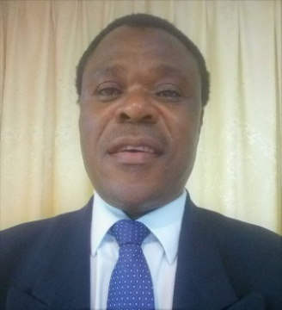
Topera

___________________________________________________________________________
- Gender:Male
- Nationality :Zimbabwe
- Current Position:Primary Class teacher
- Email: topera.383493@2freemail.com
- Position Applying for: Elementary class teacher
Personal Statement:
I am a dynamic, self-motivated and enthusiastic classroom teacher with high sense of values for the differences in students’ learning abilities and have strong interpersonal skills and intercultural awareness. I am capable ofleading well-balanced differentiated lessons which teach the core and enhances students’ academic skills and prepare them adequately, with high sense of critical thinking. I workcollaboratively with a genuine team spirit with people across the school in both curricular and extracurricular activities. I constantly improve my experience through professional development meetings.I am confident about my competence and adaptability to different situation.
Education:
Jan 2000-Dec 2001 University of Zimbabwe-Harare, (Zimbabwe).
Bachelor of Education PrimaryDegree.
Jan 1986-Dec 1989 United College of Education-Bulawayo, (Zimbabwe).
Certificate in Primary Education.
July 2018 Evaluation Credentials,WES , (United States of America)
Experience: Education:
July 2017–July 2018 International Community School -Abu Dhabi (United Arab Emirates.)
Elementary teacher: Math, English, Science, Social Studies and Moral Education.
I am also responsible of taking slow-learners, one to one.
May 2016-July 2017 Gems Westminster -RAK, (United Arab Emirates).
Grade leader for year 5.
Elementary classroom teacher: English, Math and Science.
Sept 2010-April 2016 Providence English School -Sharjah, (United Arab Emirates)
I was a supervisor for the boys.
Elementary classroom teacher for English, Math and Science.
Aug 2008-Aug 2010 Transguard CompanyDubai, (United Arab Emirates).
I was hired to train employees how to go about their duties using Basic English Language for communication.

Jan 2002-July 2008 Hillcrest International SchoolGaborone, (Botswana).
Elementary classroom teacher – English, Math and Science.
I was also acting as a sports-coordinator.

Jan1990-Dec 2001 Masvingo College- Masvingo, (Zimbabwe).
Elementary classroom teacher: English, Math and Science.
I was given the duties of a Deputy Head teacher in 1995.

Special Skills: I cancommunicateclearly inEnglish with students who use English as their second language. I am also flexible in inclusive and pragmatic style.

Achievements:
1. Most of the students whom I teach one-one have shown much improvement in class.
2. I contributed towards the formation of remedial classes rather thanprivate lessons at Gems Westminster School.
3. I introduced a class library at Providence English School.

