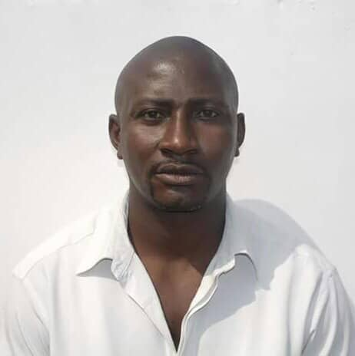
CURRICULUM VITAE

Name: William
Date of Birth: 11-06-76
Nationality: Ghana
E-mail address: William.383547@2freemail.com
Language: English
Objectives:
I am a motivated and responsible individual seeking a position as a facilitator and general welder fabricator/fitter in well-known construction company like this to apply my knowledge and my superb skills to your work force.
Working Experience:
*Unilever Ghana limited (2013-2016) welder/Fitter
*Engineers & Planners, Ghana Mining (2010-2013) Welder
*Tema Ship Yard Ghana dry-docks (2004-2010) Welder/Fabricator
*Tema oil refinery (2001-2004)welder/fitter
Responsibilities:
*Handle power tools including arc welding machines flaming cutting torches and different types of saw
*Functioned non-risky equipment and use secure labor behavior
*Combined all welding parts together by using different safety ways
*Carried out various welding tricks related with cutting,laying,repairing and fitting
*Welding in positions like level, vertical and overhead positions etc.
*The ability read blueprints to assert accurate working procedure.
*The ability to take required measurement for a well-fitting work piece.
Qualifications:
*Completed high school from Mannheim technical college (1994 Ghana)
*Completed vocational institutes, Gratis foundation Ghana (1997-2000)
*Completed National vocational training institute,(NVTI upgraded course 2016)
Technical support:
Being a major team player as employee to achieve a successful goals at all employment requirements.
Hobbies: Referees: Upon Request
*Reading Novels
*Watching movie
*Swimming.

