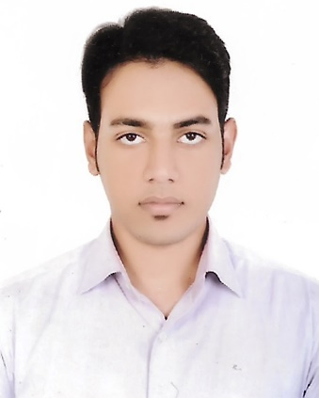
Curriculum Vitae
Shamsur

E-mail: shamsur.383558@2freemail.com

Objective  CERTIFICATE  COURSE  Academic qualification  work experience  OTHER SKILLS  SELF ASSESSMENT  REFERENCES | Willing to execute the job and show all my activities and understanding for the expansion of the business.  Completed Basic Flight Service (Cabin Crew) Course Under  JOBS A1.COM  Bachelor of Science (B.sc)  The People’s University of Bangladesh.  Department: Tourism and Hospitality Management.  Passing Year: 2016  Diploma in Hotel Management (2 Years)  National Hotel and Tourism Training Institute  Bangladesh Parjatan Corporation  Passing Year: 2012  Higher Secondary Certificate (HSC)  Tejgaon College, Dhaka.  Passing Year: 2010  Group: Business Studies  Secondary School Certificate (S.S.C)  Kashinathpur Abdul Latif High School, Pabna.  Passing Year: 2008  Group: Science  Completed six monthsattachment from ‘OCEAN PARADISE’ Hotel & Resort, Cox’s bazar.  Duration: From 1st August 2012 to 31st January 2013.  As a Senior Waiter in F&B service at ‘OCEAN PARADISE’ Hotel & Resort, Cox’s bazar.  Duration: From 1st February 2013 to 30th September 2013.  As a ‘Supervisor’ in F&B service at ‘The Mirage’ restaurant, Gulshan-1, Dhaka.  Duration: From 5th October 2013 to 25th May 2014.  As a ‘Front Desk Manager’ at ‘Garden Residence’ Transit Hotel, Sector-01, Uttara Model Town, Dhaka.  Duration: From 1st June 2014 to 30th June 2015.  As a ‘Front Office Executive’ at ‘Richmond’ Hotel & Suite, Sector-01, Uttara Model Town, Dhaka.  Duration: From 1st August 2014 to 31st May 2015.  As an `Operation Manager’ at `Thai Signatures’ Restaurant Dhanmondi Plaza AR, Level-4, Mirpur Road, Dhaka.  Duration: 1st November 2016 to 31st January 2018.  Job Responsibility  - Demonstrate co-operation and trust with colleagues, supervisors, teams and across departments.  - Maintain a high level of products and services knowledge in order to understand guests’ needs and expectations and respond adequately - Promote and explain sell excursions, services, facilities and special programs.  - Takes personal interest and pride to ensure that the work area is kept clean and in an orderly state all times.  - Does everything possible to ensure that the guests depart the hotel with a positive impression of hotel service.  Skills in Microsoft Office Application, Adobe Photoshop, E-mail and Internet & Google Drive. Hotel software –Opera, Micros.  So far I believe, I am an honest person and want to work with honesty. Responsibility is J term to which I am devoted.

