Key Skills

Site Management

Client Management

Project Management

Contract Management

Team Building & Leadership

Subcontractors’ Management

FAISAL
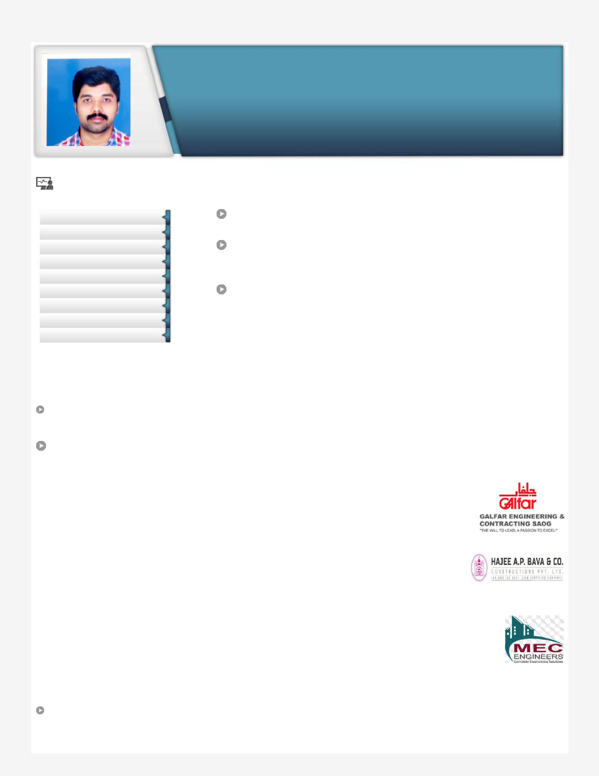

Result-oriented professional with a proven record of achievement in implementing effective ideas / strategies related to Mechanical Engineering through inspiring leadership, entrepreneurial approach and innovative excellence.

faisal.383565@2freemail.com

Profile Summary

Quality focused professional, problem solver and team leader credited with over 8 years of rich career in Mechanical Engineering.

Skilled in managing project life-cycle right from scratch encompassing monitoring, inter-discipline coordination, resource planning, documentation and hand-over.

Hands-on experience in liaising with vendors, clients, consultants, contractors, sub-contractors, Contract & Materials Purchase Cells and external agencies

Professional Qualification

B.Tech.in Mechanical Engineering from Ilahiya College of Engg. & Technology, Muvatupuzha, affiliated to Mahatma Gandhi University, Kottayam, Kerala with 70% in 2008.

Diploma in Mechanical Engineering from Govt. Polytechnic College, Perumbavoor, affiliated to State Board Technical Education, Kerala with 73% in 2005

Work Experience

Dec’11-Aug-17: Galfar Engg. & Cont. Saog as Mechanical Engineer

Work site: Petroleum Development of Oman (PDO)

Nature of work: Fabrication, flow line and hook-up for oil well

Project: Off-plot Delivery Contract (ODC)

Jan’11-Nov’11: Hajee AP Bava & Company as Mechanical Site Engineer

Work site: Monnet Ispat Energy Ltd., Raigarh

Nature of work: Fabrication & erection of mechanical structures like column, struss, gantry girder etc

Jun’08-Nov’09: MEC Engineers (India) as Mechanical Site Engineer

Work site: BPCL Cochin Refinery, Ambalamugal

Nature of work: Fabrication & erection of pipelines.

Apprentice Training

Dec’09-Dec’10: Liquid Propulsion System Centre (LPSC-ISRO) as Graduate Apprentice

Highlights:

Recognized by:

- PDO authorized as Gas Tester Permit o PDO authorized as H2S Entry Permit

o PDO authorized as PERMIT APPLICANT

NATURE OF WORK:

Fabrication, Testing & Installation of FBE COATED flow line, PE lined flow line, LLRTP for new OIL PRODUCER, WATER INJECTOR, GAS LIFT & FREE FLOW WELLS.

Fabrication ,Testing & Installation of FBE COATED HOOK UP for new OIL PRODUCER,WATER INJECTOR, GAS LIFT & FREE FLOW WELLS.

INTEGRITY REPLACEMENT, SECTION REPLACEMENT& LEAK SPOOL REPLACEMENT of old flow line.

Fabrication , Testing & Installation of DSS flow line for GAS LIFT WELLS.

UNHOOK UP & RE HOOK UP OF OIL WELLS FOR HOIST entry.

Fabrication , Testing & Installation of FBE COATED flow line ,PE lined flow line for new OIL PRODUCER,WATER INJECTOR, GAS LIFT & FREE FLOW WELLS.

COLD CUTTING & DEMOLITION of old flow line.

Conducting inspection of:

- Pipeline Fit-up & Mainline Welding, Tie-in Welding, Repair Welding, Holiday Detection, Lowering, Line Inspection &clearance prior to Hydro Test, gauging, pigging & cleaning and pre-commissioning pipeline/PE lined pipeline.

Midline tie-in of flow lines to header and hook-up to well pad & MSVs.

KEY RESPONSIBILITIES

Responsible for plan, organize and execution of piping fabrication and erection works.

Allocation of material, man power and equipment for daily work activities.

Monitor all piping installation and modification activities.

Responsible of Pressure Testing activities of piping systems.

Management of SUB CONTRACTORS &Rendering technical assistance to them.

Interfacing with QA/QC Engineer / QC Inspectors; understanding quality requirements and maintaining pertinent quality records.

Sustaining safe work environment, managing HSE/PTW norms and obtaining all necessary approvals &permits. PERSONAL PROFILE

Date of Birth:25th May 1985

Languages Known: English, Malayalam and Hindi

 |  |  | Sex | : | Male
 |  |  | Religion | : | Islam /Muslim
 |  |  | Marital status | : | Married
 |  |  | Nationality | : | Indian
 | DECLARATION :-
I hereby solemnly declare that the above information’s furnished by me are true to the best of my knowledge and belief.

 | Place : | Yours faithfully
 | Date : | Faisal

