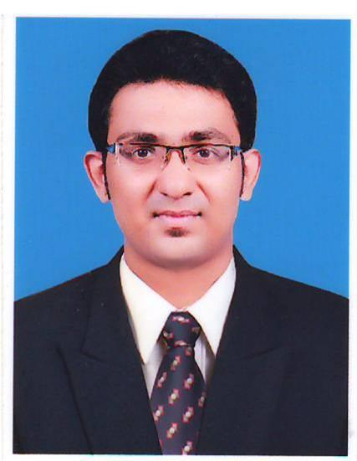
Macvin

Email id: macvin.383586@2freemail.com

Address: Bur Dubai, Dubai

CAREER OBJECTIVE

To seek a challenging and career oriented position in a dynamic organization to enhance my knowledge, skills and contribute towards the success of organization.

WORK EXPERIENCE

Worked as an Accountant in St. Milagres Credit Souhardha Co-Operative Ltd, Karwar from 01 August 2016 to 30 June 2018

Roles and Responsibilities:

- Daily voucher checking, Cash verification and Expenditure approval.
- Loan applications review and decision about sanctions.
- Monthly / quarterly crediting of interest to respective accounts as per instructions.
- Branch Auditing.
- Funds and Investment management.
- Training and guiding all staff, overall branch administration and responsibilities.
- Verification of final accounts and work done at branch level.
- Verification of monthly balance in deposit and loan account.
- Verification of staff salary.
- Sending confidential reports about staff to head office.
- Submission of Head office information to staffs.

IT EXPOSURE

- Basic Computer knowledge.
- Diploma in Computer application (DCA).
- Tally 9.0.
- VAT
- MS-Office, PowerPoint

   

EDUCATIONAL QUALIFICATIONS

 | Institution | University/Board | Percentage of marks | Year of Passing
Master of Business Administration ( Finance) | St.Joseph Engineering College, Vamajoor,Mangalore | Vishvesvaraya Technological University | 64.3 | 2016
Bachelor of Commerce | Pompei College, Aikala, Mangalore | Mangalore University | 78.58 | 2014
12th | Pompei College, Aikala, Mangalore | Department Of Pre-University Education | 81.5 | 2011
10th | Dr.M.R.S.M English Medium School, Thokur, Mangalore | Karnataka State Board Of Secondary Education | 69.92 | 2009

PERSONAL SKILLS

- Sincere and Optimistic.
- Able to establish and maintain a good working relationship with the staff at all levels.
- Good team working skills.
- Self-motivated “can do” attitude with a strong desire to succeed.
- Easily cop up with any kind of situations, individuals or working atmosphere.
- Determination, dedication and discipline.

PROJECT DURING THE COURSE

Performance Evaluation of Select Mutual Fund Schemes in India: A Study With Reference To Bajaj Capital Ltd, Mangalore

EXTRA CURRICULAR ACTIVITIES

- Attended workshop on EMPLOYABILITY SKILL held in St.Joseph Engineering College, Vamanjoor.

- Attended STUDENT DEVELOPMENT PROGRAMME conducted by Peagasus Institute for Excellence Bangalore
- Participated in ETTIN-2015 a National Level PG FEST at Justice K.S Hedge Institute of Management NITTE and SENTIA-2015 a National Level PG FEST at M.I.T.E Moodabidri.
- Participated in seminars held in various colleges.
- Actively volunteered in the cultural events and been part of the co-coordinating team.
- Actively volunteered in the blood donation camps.

PERSONAL PROFILE

Date of Birth : 18-04-1993

Gender : Male

Marital Status : Single

Nationality : Indian

Visa Status : Visiting visa

Driving License : Valid Indian License

