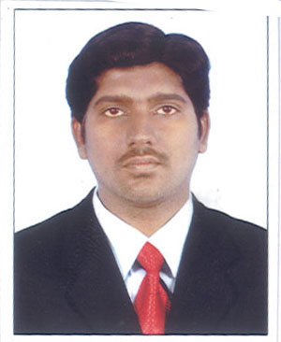
JAFER

OBJECTIVE

To be a successful professional and to work in a challenging and creative environment that contributes

towards the goal of organization.

CONTACT

Email:-

Jafer.383608@2freemail.com

Nationality: Indian
Gender :- Male

DOB: 10 Oct 1989

Marital Status:-

Single

Conversant In:-

English,Hindi, Arabic, Tamil, Malayalam

EXPERTISE

System peripheral technician
Photocopier, printer and fax machines (All Brands)
Networking & Router configuration
All other basic function of computer

EXPERIENCE

Organization : Hajarasiah Electro service EST
Designation : IT Technician
Duration : Jan 2016 to still doing
Riyad KSA

Organization : Score Information Technologies LTD
Designation : IT Technician (TSP)
Duration : Jan 2013 to Dec 2015
Kerala India

ACADEMIC DETAILS

Qualification : BSc Information Technology
University :Calicut University.
Percentage : 71%
Year of Passing : March 2012

ADITIONAL QUALIFICATION

Cisco Certified Network Administrator (CCNA)
Diploma in Computer Hardware
Diploma in CCTV

PROFFESIONAL STRENGTH

Photo copier and Printer Repairing
Photo copier, Printer ScannerFax Machine
All Brands
Hardware & Software support on client PC &
Printer Configuration
Network installation & configuration
Network installation and configure(LAN&WAN)
CCTV Installation and configuration

Declaration

I JAFER, affirm that the information compiled above is precise and accurate in its entirety to my
knowledge.

