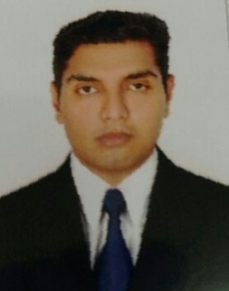
Fahad
Fahad.383648@2freemail.com

Career Objectives:
To build career in a growing organization where I can get the opportunities to prove my abilities by accepting challenges, fulfilling the organizational goal and climb the career ladder through continuous learning commitment.

Personal Data:

Date of Birth: 29-08-1988
Nationality: Bangladeshi
Place of Birth: Chittagong
Marital Status: Single
Religion: Muslim
Language Skills: English, Urdu, Arabic (Little).

Education:
- Diploma ( American High School )
- GPA 2.5
- Computer: MS OFFICE 2010

Work Experience:
- Oxygen Welder and Light Vehicle Driver in Mussafah Industrial Area since 3 years.
- Worked Part time as a Nokia Promoter
- Worked Part Time as a Xiomi Promoter At Ashtel

Key Skills
- Good communication skills
- Committed to delivering a high level of customer service
- Flexibility to respond to a range of different work situations
- Willingness to learn
- Passion for excellence in service and team-work
- Eye for detail to achieve operational excellence
- Determination to succeed

DECLARATION
I hereby declare all the above information’s are true and correct to the best of my knowledge and belief.

