RESUME
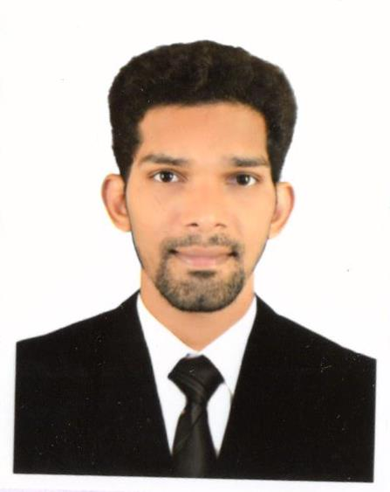Rajasab

Email: rajasab.383663@2freemail.com

CAREER OBJECTIVE :
An optimistic “never giving up” attitude will ensure my best performance at all times. An unending desire to learn and communicate while I work and providing my efforts to attain job satisfaction.

PERSONAL AND PROFESSIONAL PROFILE :
Able to work under tremendous pressure and meet deadlines with ease and efficiency. Good inter personal relation and communication skills.

EDUCATIONAL QUALIFICATION :
- Completed H.S.S.C through Goa Board in March 2006
- Completed S.S.C through Goa Board in March 2004.

ADDITIONAL QUALIFICATION :

- Computer Applications inclusive of Computer Fundamentals, DOS, Windows, Word, Excel, PowerPoint &internet.
- Completed Tally 9 from Digicom computer Education in panajim Goa 2010.

OTHER ACHIVEMENTS :
- Received “Product Champion Certificate” For Kabbadi in MES College and other Athletics medals.
- Many more in Dance, Quiz and Creativity competition.

WORK EXPERIENCE :

1 Worked for City Center for Splash outlet in State of Kuwait.
Designation : Sales Executive/ Customer Service agent
Duration : 1 year

JOB RESPONSIBILITIES:
- Customer service,
- Push products to achieve targets.
- Supervise Floor and to maintain display
- Help colleagues, opening and closing task.

2 Worked in Saudi Arabia Jeddah, as an Office Secretary for the period of 1 year
Designation : Office Secretary
Duration : 1 year

3.Worked for John Players franchise showroom in goa India Designation : Sales person
Duration : 1 Year
Jobdescription & Responsibility:
- To greet customers for the day welcome them to store
- To know their need and looking for
- Show them varieties of their choice
- Let customers havesome time to think & decide
- Make sure sale happen while reaching customers satisfaction

3 Worked for Altisource business solution in Goa
Designation : call center agent/ specialist
Duration : 1year 6months

JOB RESPONSIBILITIES :
- To make calls to customers inform the about their mortgage loan amount
- To convince them to pay the amount in convenience way
- To generate GPN letter to the customer on behalf of clients
- Checking KYC of customers.
- Keeping track of clents and follow-up’s
- Maintaining sales track and updating, forward to Manager

Total Experience in Sales/ Customer service 4years

SKILL SET
- Good convincing & communication skills in English, Hindi & Arabic.
- Computer Knowledge.
- Fast Learner.
- Customer Satisfactory.

Personal Details

Date of Birth : 07/04/1989

Gender : Male

Marital Status : Single

Religion : Muslim

Nationality : Indian

Languages known : English, Hindi, Arabic, Konkani & Marathi.

