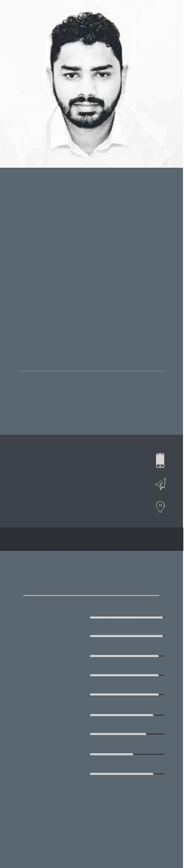

A highly dedicated and creative graphic designer with over eight years experience working on several different formats of graphic design including , print, web, social media and user

THUSHANTHAN

Work Experience

March 2016- | Graphic & Ui Designer |  |  | Eyepax IT Consulting (Pvt) Ltd
March 2018 | Directed and designed creative concepts for website, posters, flyers and
 | stationeries. Designed visual mock-ups from wire frames to high-quality
 | user interfaces and visual designs for web and mobile applications . Filmed
 | and edited interviews and corporate promotional videos. clients I have
 | worked with;

interface for mobile and web . I am looking for a challenging, fast-paced environment within media to utilise my creative knowledge and develop my creative skill-set further.

July 2014-

July 2015

2009-Present

Graphic & Ui Designer Glia.lk (Pvt) Ltd

Worked on a variety of projects from user experience web design to print advertisements, including logos, brochures, posters,flyers and stationeries. Designed graphics for social media. Client I have worked with;

Freelance Graphic Design & Photography

Date of Birth Nationality

17-12-1987 Srilankan

Thushanthan.383695@2freemail.com
Dubai, UAE

Visa Status: Visit Visa

Software

Photoshop

Illustrator

Lightroom

Sketch

Adobe XD

Premiere

After effects

3d Studio Max

Google Adwords

Designed print materials and websites for client ranging from small online merchants to large corporates. Photographed products and corporate events. Clients I have worked with;

Education

Bachelor | Bsc in Computing with Interactive Media (Hons)
2011-2014 | Buckinghamshire New University, Followed in South Asian Institute
 | of Medicine & Technology (SAITM) Srilanka. Completed 1st year in
 | INTI International University Nillai, Malaysia.

Diploma | Higher Diploma in Interactive Media
2011-2013 | South Asian Institute of Medicine & Technology (SAITM)
2007-2008 | Diploma in Multimedia
 | Wijaya Graphics Colombo Srilanka
School | Advance Level
2007 | Completed Advance level with two Credit pass and one Simple
 | passes in commerce stream at St. Thomas’ College Bandarawela.

Skills

Photography |  |  |  |  |  |  | Language Skills
Video Editing |  |  |  |  |  |  | English
Social Media Markerting |  |  |  |  |  |  | Tamil
UX Design |  |  |  |  |  |  | Sinhala

