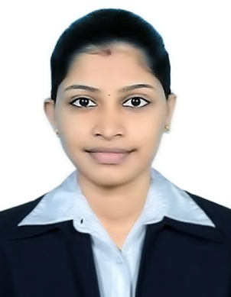
CURRICULUM VITTAE

ASWATHI

E-mail: aswathi.383725@2freemail.com

OBJECTIVE
To work in an inspiring competitive and challenging environment so as to contribute the best of my constructive and creative abilities as well as my sincere efforts towards the accretion, eminence and prosperity of the organization and also to grow as successful professional.

SKILL SET
- Ability to plan and prioritize work activities effectively
- Sincere and flexible to any work environment
- Highly disciplined
- Excellent team player and with resulted oriented
- Dedication, Sincere & Working are base
- Good communication skills
- Good organizational skills
- Knowledge of medical terminology
- Willingness to learn new things and the ability to understand the, quickly
- Ability to work as a part of a team or individually
- Optimistic

ACADEMIC BACKGROUND
- Qualified Dubai Health Authority Examination in August 2018
- DHA license holder (Ref: DHA/LS/2262018/823617)
- B pharma with 72% (Rajiv Gandhi University of health & science, Bangalore Karnataka) 2011-2015 batch in Srinivas College of Pharmacy Valachil, Mangalore, Karnataka
- Plus Two (Kerala Board) in GHSS UDMA , Kasargod ,Kerala ,2011
- SSLC (Kerala Board) in GHSS UDMA, Kasargod , Kerala, 2009
PROFESSIONAL EXPERIENCE
- Worked as Pharmacist in Kasturba Hospital (KMC) Manipal, Karnataka in India.
- Worked as Pharmacist in Haivals Medicals in Udma, kasargod ,Kerala in India
- Simcon Laboratories Mangalore, Baikambady, Karnataka (90 days experience in drug manufacturing unit as a part of study)

EXTRA CURRICULAR ACTIVITIES
- Participated in a National Seminar “Optimization Techniques & Research Methodology by RGUHS, Bangalore.
- Participated in social Service works as part of NSS

PERSONAL DETAILS
Sex : Female
Date of Birth : 29/10/1993
Marital Status : Married
Nationality : Indian
Languages Known : English, Hindi, Malayalam, Kannada & Tamil
Visa Status : Resident visa

TECHNICAL SKILLS
- Application Software (MS Word, MS PowerPoint & MS Excel)\

HOBBIES
- Reading
- Playing Badminton
- Dancing

CONCLUSION
I kindly request you to provide me an opportunity serves under your esteemed organization. If I am selected would assure you that I will discharge my duties to the entire satisfaction of my superiors.

ASWATHI

