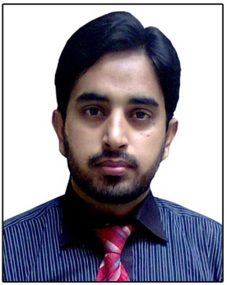
RANA
Rana.383742@2freemail.com

CAREER OBJECTIVE:
To Serve an Organization under Competitive and challenging atmosphere to
Prove the enthusiasm technical skills in the best interest of the organization
EXPERIENCE:
OFFICER OG-III, (Jan, 2016 to Present)
Bank ID: 11401
Bank Al Habib Ltd.
Main Branch Okara.

CASHIER:
Zarai Taraqiati Bank Limited. (2012 TO Dec, 2015)
PI.NO.4934
Responsibilities:
- Hand on Experience
- LAMS -LOAN APRAISAL MANAGEMENT SYSTEM, | - CDMS- CENTRAL DEPOSIT MANAGEMENT SYSTEM
- SDMS - Security Document Management System | - ENTER PRIZE RESOURCE PLAINING
- ICRMS- Internal Credit Risk Management System | - NIVS- National Identity Verifications System
- Di-MIS- Dynamic Integrated MIS | - RRIS- Regulatory Reporting Information System
- HAMS- Hajj Applications Management System
- TO MAKE PAYMENT OF SANCTIONED LOAN  - ISSUE CHECK BOOKS  - RECEIVE LOAN INSTALMENTS  - MAINTAIN BANK ACCOUNTS  - MAINTAIN CDMS (CENTRAL DEPOSIT MANAGEMENT SYSTEM)  - MAINTAIN CFOCS ( CENTRALIZED FIELD OPERATION COMPUTERIZATION SYSTEM) | - ISSUE CHECK BOOKS  - MAINAINT CHECQUE CLEARING NIFT (NATIONAL INSTITUTIONAL FACILITATION TECHNOLOGIES (PRIVATE) LTD.)  - MAINTAIN CASHIER’S SCROLL  - MAINTAIN TRACTOR REGISTRATION  - TO MAKE PAYENTS OF BRANCH EXPENSES  - SUBMIT CREDIT INFORMATION REPORT

PERSONAL INFORMATIN:
Father Name : Rana Muhammad Razzaq
Nationality :Pakistani
Domicile: Okara
NIC # : 35302-8238653-7
Marital Status : Married
Birth Date : 28-04-1986
EDUCATIONAL INFORMATION:
Degree | Institution | year | Subjects | Div/Grade
LLB | Multan Law College BZU Multan Pakistan | 2017 | Administration Law, Company Law &others | 2nd
CBT TRAINING | BANK AL HABIB | 2016 | Banking Operations | A+
Basic Banking | ZTBL, Staff College | 2014 | ERP,EBS,CDMS,AML | A++
CCNA | Cisco Certified | 2009 | Com.Networks | A++
CCNA -Training | Corvate LHR | 2009 | Com.Networks
DIT | SGC Okara | 2006 | IT Certificate | A++
Graduation | Punjab university | 2006 | Journalism | 2nd
Intermediate | BISE Lahore | 2004 | Com.Sci | 2nd
Matriculation | BISE Lahore | 2002 | SCIENCE | 2nd

SKILLS AND QUALITY:
- Good at Communication Skills
- Ambitious and motivational attitude
- Attain Good knowledge and grip in computer&Always participated in extracurricular activities at significant level

References:
- Available Upon Request4

