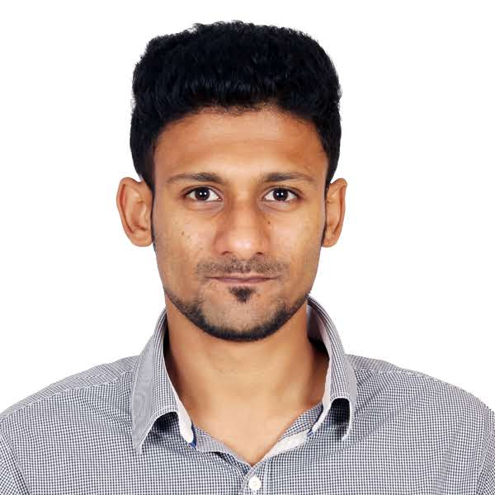
FEBIN

Febin.383748@2freemail.com

Visa Status: Visit

OBJECTIVE

Qualified engineer with 2 years of work experience as a Procurement Specialist. I hope to see myself working in an innovative and competitive organisation to contribute to individually and to my team with hard work, sincerity and dedication.

SKILL SUMMARY

TECHNICAL SKILLS
- MS Excel, Office, PowerPoint, Outlook
- ERP systems- OracleR11/R12/CLOUD, SAP, Maximo
- Computer language: C & C++ [Basic level], HTML
- GSM, RTC, LCD (16×2), ATMEGA 16/17, AURDUINO, PCB
- Advanced diploma in embedded system(Linux OS, ARM)

INTERPERSONAL SKILLS
- Confident, determined, hardworking, quick learner.
- To work under pressure and achieve targets.

PROFESSIONALSUMMARY

Work Experience:
Oracle India Pt. Ltd: April 2016 -up till- August 2018
Designation: Analyst
- Creating Purchase Order towards requests of Services & Products [IT, Real estate, Legal, Marketing, Facilities, Events, Food & Beverages] that are made on the Oracle R12, CLOUD.
- Vendor catalogue management: Working with Vendors to learn the pricing on their Goods or Services and choose between vendors for the service. Finally to prepare a Catalogue lists.
- Review Agreement clauses: Review contract terms and documents between Vendor
- Reporting: Maintaining open Reports of internal orders and of vendor details on regular basis to provide information to be updated.
- Budget orders: Handling high valued orders.
- WebEx:actively engage in monthly calls with select priority vendors to ensure their services have been paid for. We also discuss on on-going circumstances and find better ways to make the process much simpler on both ends.
- SPOC for NORDIC countries:I was theSPOC for all NORDIC countries. Successfully meeting the assigned tasks and goals to keep our payment record intact with the vendors.
- Process support: Supported to functional teams [scanning, payments, contracts, Invoicing]
- Attaining KPI: Active Discussions to realise, manage and prepare a work around.
- Improved TAT: Improving job quality & speedy work process.

EDUCATIONALBACKGROUND
- Bachelors in Engineering – E&C [VTU]
- Schooling: St. Joseph’s Boys’ High School

Extra-curricular achievements:
- Played Soccer for College University, Corporate level.

PERSONALINFORMATION
Nationality: Indian
Status: Single
Languages: English, Hindi, Malayalam, Kannada, Tamil, Arabic [Beginner]
Date of Birth: 16/03/1992
Gender: Male
Driving License: Yes (Indian)

