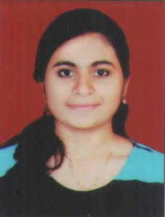
Nisha
nisha.383756@2freemail.com
Dubai UAE.

PERSONAL PROFILE
Gender : Female
Date of Birth : 27/11/1996
Marital Status : Single
Nationality : Indian
Religion : Catholic
Languages known : English, Hindi, Marathi & Konkani.

OBJECTIVE
Seeking full-time career opportunity to succeed in an environment of growth and excellence, to hone my
technicalandprofessional skills to help me achieve personal as well as organizational goals.

EDUCATION
Course | Institution | Board | Year | Percentage
Bachelors in Accounting and finance | St. Gonsalo Garcia College of Arts and Commerce | University Of Mumbai | 2017 | Final year 66.42
HSC | St. Xavier’s Jr College Of Science and Commerce | Maharashtra Board | 2014 | 80.62
SSC | St. Anthony’s High School | Maharashtra Board | 2012 | 62.60

PROFESSIONAL EXPERIENCE

ACCOUNTS ASSISTANT
"Magnus Telecommunications Pvt. Ltd.", Mumbai India.
10/06/2017-05/09/2018
Key Responsibilities:
- Posting of purchase, sales, payments, receipt collections and journal vouchers.
- Handled day to day cash and bank transactions.
- Prepared outstanding list of debtors and making payment follow up.
- Reconciliation of bank statement.
- Maintained cash transactions, petty cash book and managed accounts payable.
- Managed day in and day out operations of accounts department.
- Prepared quarterly VAT Return.
- Prepared Monthly GST return.
- Maintained salary registers in Ms-Excel.
- Maintained balance sheet and profit & loss.
- Establishing and maintaining fiscal files and records to document transactions.

TECHNICAL SKILLS
- Tally ERP 9
- Ms Office

INTERPERSONAL SKILLS
- Creative thinking
- Strong work ethic.
- Dedication towards work.
- Problem solving
- Positive and team-oriented attitude
- Hard working

CURRICULAR ACTIVITIES
- Successfully Completed Maharashtra State Certificate in Information Technology (MS-CIT).

INTERESTS
- Cooking
- Playing badminton and carrom
- Listening to music

DECLARATION

I hereby declare that the above provided information is authentic to the best of my knowledge.

