United Arab Emirates
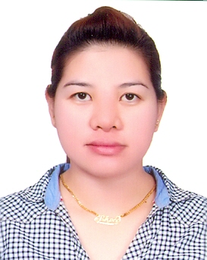

Email ID : beatrez.383769@2freemail.com

BEATREZ
Career Objectives

I have 10years of experience in spa industry as a Massage Therapist and a Spa Supervisorwhere I obtained a number of professional skills: staff management, customer service, teamwork, administration, and communication skills.

I am focused on building a successful career within an international hotel chain or company. I have deliberately looked for work experience in this area so I know that the fast paced, result-oriented environment will give me the challenge I thrive on. I am a hardworking and strong relationship builder, resilient and motivated by success.
Career History

- MASSAGE THERAPIST January 10 2016 - Present
SHARJAH GRAND HOTEL
Sharjah, United Arab Emirates

- SPA SUPERVISOR December 2013-December 2015
RAMADA BEACH HOTEL
Ajman, United Arab Emirates

- MASSAGE THERAPIST May 2009-May 2011
PURITY HOME SERVICE MASSAGE
Moonwalk, Paranaque, Philippines

- MASSAGE THERAPIST March 2008 -August 2009 YOUR SERVICE HOME MASSAGE
Ayala Alabang, Philippines

- SPA THERAPIST February 2007- February 2008
WENSHA SPA “Delta” Timog Quezon City, Philippines

- SPA THERAPIST January 2006-January 2007
BACARA SPA
Paranaque City Philippines
Education

San Isidro Lupao Elementary School 1994 to 2000 Constancio Padilla National High School 2000 to 2004 Course : Vocational Under Graduate
Personal Information

Date of birth : July 03, 1987 Status : Single Nationality: Philippines Gender: Female
Visa Status: Employment Visa

