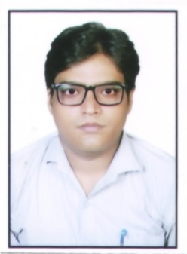

Ahraj

Email • ahraj.383771@2freemail.com

Performance Summary: Creative versatile and hardworking professional with 7 years dedicated experience in Offset Printing & graphic designing industry. Working knowledge of design principles, practices, and methods of digital art, production procedures, printing system, and industry terminologies.

Creative Experience in the Following:
Print • Products Photography • Brochures & Flyers • Logos & Business Cards
Posters • Photograph Restoration • Packaging Specialist • Multitasking in press room

PROFESSIONAL WORK EXPERIENCE
- Organization: K. G. N. Packagers
- Tenure: April - 2015 to August - 2018.
- Designation: Graphic and Packaging Designer

Responsibilities:

- Design and layout die lines and package graphics for new and existing products using CorelDraw,
Illustrator and Photoshop.
- Designed layout and graphics and prepared for print.
- Created packaging specifications and constructed mock-ups for client presentation.
- Met with sales department and clients to review and revise artwork.
- Thinking creatively to produce new ideas and concepts and developing interactive design
- Handles the duties of the Printing Press Production Manager in his absences.

- Organization: Quality Offset Printers
- Tenure: April - 2011 to March 2015
- Designation: Graphic Designer

Responsibilities:

- Ideate and execute branding solutions including logos, color schemes, and graphic themes for new and existing lines.
- Coordinate design projects as directed through multiple associates from concept to final delivery of assets to factory.
- Handle multiple assigned projects with various and fluctuating priority levels and short deadlines simultaneously.
- Create vivid concept imagery and physical packaging mock-ups for sales presentations to clients.
- Initiated troubleshooting of hardware & software.

- PROFESSIONAL QUALIFICATION:

Graphic Designing from MAYA ACADEMY OF ADVANCED CINEMATICS (MAAC)

- ACADEMIC QUALIFICATION:

Year | Course | Board/ University
2017 | Graphic Designing | MAAC
2010 | B.Com | C.S.J.M
2006 | Intermediate | U.P. Board
2004 | Matriculation | U.P. Board

SOFTWARE EXPERTISE
• Photoshop | • Illustrator
• CorelDraw | • InDesign

- LANGUAGES KNOWNS:

Language | Read | Speak | Write
Hindi
English

PERSONAL PROFILE:

Date of Birth : 22/07/1989
Material Status : Married
Sex : Male
Language : Hindi, Urdu, English
Nationality : Indian

Visa Status : Visit Visa

