 | HUBERT, ECE, ECT
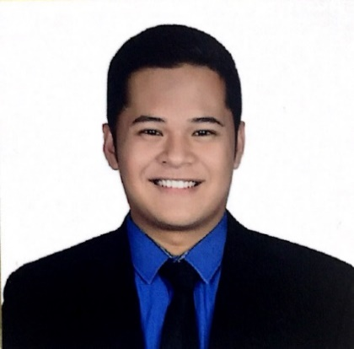  Personal Information  Address: Dubai, UAE  Nationality: Filipino  Visa Status: Visit Visa  Email: Hubert.383792@2freemail.com  Strengths and Skills  - Knowledgeable in Network performance monitoring tools such as:  - Costumer Service Platform (CSP)  - Service Provisioning System (SPS)  - Astellia  - Intelligent Network (IN Tools)  - NetScout  - Costumer Experience Management (CEM)  - Huawei Performance Management (PM)  - Secure CRT  - Traffica and Nastar for SMS/Voice/Landline  - Putty  - Knowledgeable in subscriber SIM card cycle status and Network Architecture  - Knowledge in network security and architecture  - With experience in using remote desktop utilities to troubleshoot and resolve user’s problems  - Strong communication and documentation skills  - Fluent in English both in verbal and written |  | Career Objective:  To be part of a company that provides an opportunity for mutual growth and where I can utilize and develop my analytical and technical skills.  Credentials  Philippines Licensed Electronics Engineer (ID# 0067678)  Philippines Licensed Electronics Technician (ID#0014627)  Educational Background:  Bachelor of Science in Electronics and Communications Engineering  University of Batangas, Philippines  Work Experience  Service Management Engineer 2017 - 2018  Smart Communications Inc.  Parañaque City, Philippines  Responsibilities:  - Troubleshoot 2G (GSM), 3G (UMTS/WCDMA) and 4G (LTE) Data services issues and network fault  - Perform 24/7 monitoring and troubleshooting network and services problems, issues, outages, and alarms  - Coordinate with Customer Service, Technical Support, Network Operations, Field Operations, and other departments in resolving services and network access  - Ensure tickets and service requests are being delivered and isolated to the rightful team or department for proper handling and troubleshooting  - Coordinate with Regional Service Assurance Group for coverage issues and KPI services  - Check for sites that is not on-air and coordinate for updated roll-out of sites with included activities to be performed  - Provide help desk support and resolve problems to the end user satisfaction  - Provide prompt and accurate feedback to customers  On-the-Job Trainee(300 hours) May to July 2016  Globe Telecommunications Inc.  Makati City, Philippines  Responsibilities:  - Identification and classification of FMEA(Failure mode and effect analysis)  - Rating of Incident Severity, Detection, and Occurrence in every MOP (Method of Procedure)  - Assistance in network configuration through Putty  - Inventory of network incident failures and solutions for the entire year  - Inventory of VLAN configurations  - Inventory of used and unused IP addresses

