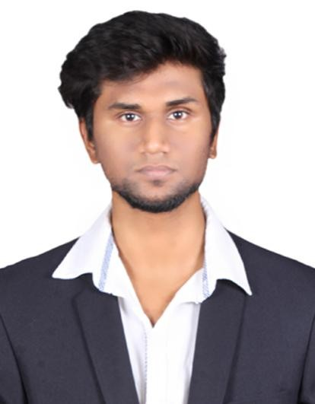CURRICULUM VITAE

AMAN

B.E. Mechanical Engineering

E-mail: aman.383829@2freemail.com

-----------------------------------------------------------------------------------------------------
CAREER OBJECTIVE:
ToobtainachallengingpositionwithagrowingorganizationwhereIcan utilizemyskillsandknowledgeandtoworkforthegrowthoftheinstitution.

ACADEMIC QUALIFICATION:

S.NO Course Name of
Institution
Board/

University
Year of pass
Percentage/ CGPA

B.E in mechanical engineering
1
M.I.E.T Engineering college, Gundur, Trichy.
Anna
University,
Chennai. 2017 6.4

Diploma in mechanical
2 engineering
M.A.R polytechnic college, viralimalai,
Pudukkottai Dist.
State Board,

Tamilnadu. 2013 70.4

3 SSLC
National college higher secondary school, Trichy.
State Board,

Tamilnadu. 2010 68.8

AREA OF INTEREST:

Manufacturing.
Production.

TECHNICAL SKILLS:
Autodeskinvertor, Autocad.
C,C++.

EXPERIENCE :

Worked as a Processing Executive in MMC Infotech Services PvtLtd.,Trichy
From Oct 2017 to July 2018
PERSONAL SKILLS:

Abilitytoblendintoateam.
PositiveAttitude,Commitmenttowork,Sincerity&Punctuality.
Goodcommunication.
ICanadaptmyselftoanysituation

MAIN PROJECT:

Crashanalysisforbodyframeofcarusingfiniteelementanalysis.
AREA:Softwareprogramming.

INDUSTRAIL VISIT:

SHANTHI GEARS at Coimbatore for 1 day.

EXTRA CURRICULAR ACTIVITIES:

Playing Football.
NCC Cadet.

PERSONAL DETAILS:

Date of Birth : 18-07-1995

Sex : Male Nationality : Indian Religion : Muslim Marital Status : Single
Languages Known : English, Tamil, Hindi.

DECLARATION

“I hereby declare that the above information are true to the best of my knowledge.”

