CURRICULUM VITAE
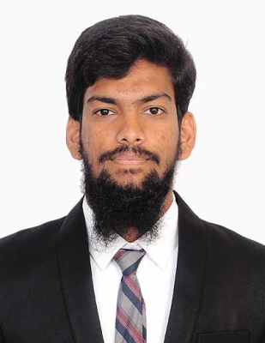

Abdul

Email address: abdul.383872@2freemail.com

OBJECTIVE:

To associate with an organization which progresses dynamically and gives me a chance to update my knowledge and enhance my skills and be a part of the team that excel in work towards the growth of the organization and gives me satisfaction thereof. Ability to work independently with high motivation towards new knowledge and a good team worker with evidence by my excellent performance in my professional career.

WORK EXPERIENCE:

3 Years of Professional Experience
`
Amazon (February 2016 – June 2018)
Position: Senior Customer Service Associate

Duties & Responsibilities

- Worked in Retail team- handling customer queries on shipment details, product issues, processing replacements, refunds and questions relating to items available in fulfillment center (Warehouse).
- Follow up with carriers to make sure that the packages are delivered on time.
- Provide technical support and service to customer in regards to the status of orders and fulfill delivery commitment.
- Answering all the customer queries with best Customer satisfaction factor.
- Troubleshooting the problem by analytical and problem solving techniques.
- Exhibit required knowledge and use of departmental resources, policies and procedures as and when needed.
- Demonstrate clear and polite written communication.
- Answer messages in authorized email queues as directed by workflow and supervisor.
- Escalate customer issues appropriately and correctly.
- Understand the need of the customers and correctly use all available tools to resolve as expected.
- Following up with customers when required and escalating problems using the correct escalation matrix

Process Associate:

Tech Mahindra

Hyderabad, INDIA – June 2014 – February2015

Duties & Responsibilities

- Obtains client information by answering telephone

- Using Reverse phone search tools, Switchboard, Dexknows and Superpages.

- Determines eligibility by comparing client information to requirements.

- Informs clients by explaining procedures; answering questions; providing information.

- Records customer inquiries by documenting inquiry and response in customers' accounts.

- Improves quality service by recommending improved processes.

- Identifying new product and service applications.

- Updates job knowledge by participating in educational opportunities.

EDUCATIONAL BACKGROUND:

Bachelor of Commerce

Osmania University

Hyderabad, India

June 2012-May 2016

Intermediate
Board of Intermediate Education
Hyderabad, India
June 2010-March2012

Azra Public School

Central Board of Secondary Education

Hyderabad, India

March 2000 - April 2010

Relevant Qualifications:

Languages:

- English: Fluent in speaking and writing

- Urdu: Mother Language

PERSONAL INFORMATION:

Nationality: Indian

Marital Status: Single

Date of Birth: May 13, 1994

Place of Birth: Hyderabad, INDIA

References:

Will be provided on demand.

