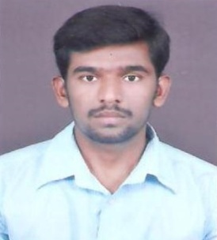
Email: selvam.383876@2freemail.com

SELVAM
OBJECTIVE

To work in a challenging environment that promises growth as well as opportunity to learn more. To shoulder responsibilities effectively and contribute towards the growth of the organization with the skill I possess and have developed.
EDUCATION

Qualification | Year | Institution | Percentage
M.Sc Mathematics | 2012-2014 | The New College (Autonomous) Chennai | 63%
P.G.D.C.A | 2011-2012 | TCDS Computer Education Chengam | 78%
B.Sc Mathematics | 2007-2010 | Shanmuga Industries Arts & Science College,Thiruvannamalai | 51.25%
WORK EXPERIENCE

Sri Annalakshmi Restaurant – Chennai
RESTAURANT MANAGER August 2014–December 2017
- Oversee all front and back of the house restaurant operations.
- Ensure customer satisfaction through promoting excellent service.
- Respond to customer complaints tactfully and professionally.
- Analyze staff evaluations and feedback to improve the customer’s experience.
- Project future needs for goods, kitchen supplies, and cleaning products; order accordingly.
- Look for ways to cut waste and decrease operational costs.
- Train new employees and provide ongoing training for all staff.
- Preparing and presenting staffing/sales reports.
- Setting targets.
- Promoting and marketing the business.
- Overseeing stock levels.
- Planning menus.
- Making improvements to the running of the business and developing the restaurant.
- Control operational costs and identify measures to reduce waste.
Courtallam Border RahmathKadai - Chennai
RESTAURANT MANAGERFebruary 2018 – August 2018
- Supervised 20 plus employees during ashift.
- Developed and implemented budget plans to successfully increase profit margins. Createdand implemented plans to develop effective advertising to increasesales.
- Ensure food safety and quality of food as well as customersatisfaction.
- Managed invoices & receipts for all stock; conducted the financial report at the end of eachday.
- Resolved problems amicably faced by floor staff members and thecustomers.
- Monitored cost control, handled cash, ordered inventory and prepared nightly closingreports.
- Responsible for all administrative aspects of theoperations.

PERSONAL INFORMATION
Date of Birth :09 – June - 1989
Sex :Male.
Nationality :Indian
Marital Status :Single.

DECLARATION
I, hereby declare that the information contained herein is true and correct to the best of my knowledge and belief.

