POOJA  Email: pooj.383883@2freemail.com | 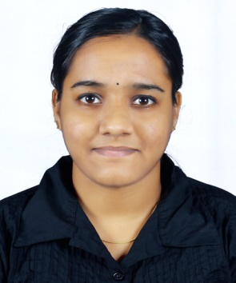

Career Objective

Fast-learning recent multi-skilled technical post-graduate enthusiastic about working in any type of business environment.Highly motivated to work in team-oriented and collaborative environment.

Education

- Master of Computer Application (MCA)from MG UniversityKerala (2014-2016)

- Bachelor of Computer Application(BCA) from MG UniversityKerala(2011-2014)

Experience

Software Engineer (Tegain Technologies Pvt.Lmt)(2017June–2018 May)

Worked as a Software Engineer atTegainTechnologies Pvt Lmt.

✓ Producing clean, efficient code based on specifications
✓ Testing and deploying softwares
✓ Fixing and improving existing software
✓ Integrate software components and third-party programs
✓ Gather and evaluate user feedback
✓ Development of user friendly web pages using Html,CSS, JavaScriptand JQuery

✓ Maintaining and improving websites

- Creation and maintaining of databases for websites

Software Skills

Languages Known: Python (Django), ASP.Net (MVC),PHP,Java,C,VB,CPP
Database : MY SQL, MS SQL server 2008
Softwares : MS Word,MS Excel,MS PowerPoint
Project Experience

✓ Ecommerce Software (Python)

✓ LawApp (Python)

- Smart Parking(Main Project)

- MGNREGS (Mini Project)

✓ Library Management Software:

   ✓ Smart Billing
Personal Details

✓ Gender : Female

✓ Date of Birth : 17-May-1994

- Languages Known : English, Malayalam, Hindi, Tamil

- Nationality : Indian

✓ Visa Status : Visit Visa

Positive Traits

- Honest & Punctual.

- Computer Knowledge.

- Hardworking.

- Motivator

- Adaptable

- Ready to accept challenges

- Learn with practical approach.

Declaration

I do here by declare that above information is true to the best of my knowledge.

Pooja

