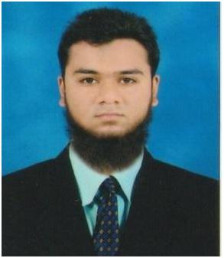

AKBAR

ACCOUNTANT

Akbar.383899@2freemail.com

SUMMARY

I’m professionally experienced in Analyzed, examined, and interpreted account records, compiled financial information, and reconciled reports and financial data

EXPERIENCE
ACCOUNTANT

Responsible for the general accounting function including preparing journal entries, maintaining balance sheet schedules and ledgers and account and bank reconciliations. Assisting with monthly closings and account analysis and supporting the senior accountant in carrying out the responsibilities of the accounting department

JR.ACCOUNTANT- AVON PHARMA MACHINES PRIVATE, MUMBAI, INDIA. — 2017-2018.

DUTIES:

- Preparing sales invoices & the upkeep of an accurate accounts filing system.

- Preparation and input of month end journal vouchers.

- Responsible for financial accounts including budgets and cash-flow.

- Preparation of bi-weekly invoice and expense claim payment runs.

- Assist in the preparation of monthly balance sheet account reconciliations.

- Inputting of supplier invoices and employee expense claims to the ledgers.

EDUCATION

B.COM (ACCOUNTING & FINANCE )

Mumbai University- 2016-17

SKILLS

Technical Skills

- TALLY ERP.9.
- MSCIT.
- DTP.

SKILLS

Non-Technical Skills

- MS OFFICE.

CERTIFICATE

- TALLY ERP. 9

- DESKTOP PUBLISHING
- MSCIT

INTERNSHIP

- Worked with Glorious Digital Solutions as a fresher Jr.Accountant.

- Worked with Sheikh & Associates (CA) as an Account Asst. on Tally Erp 9 & MS Excel.

EXPERIENCED IN:

- Knowledge of accounting principles and practices.

- Knowledge of finance principles.

- Knowledge of financial reporting.

- Knowledge of local, state and federal laws regarding accounting, finances and taxation.

- Technical accounting skills.

- Previous experience of general accounting.

- Proficiency in relevant accounting software.

PROFESSTIONAL SKILLS:

- Strong organizational skills

- Effective time management

- Analytical reasoning

- Account reconciliations

- Strong communication skills

I hereby declare that all the details furnished here are true to the best of my knowledge

AKBAR

