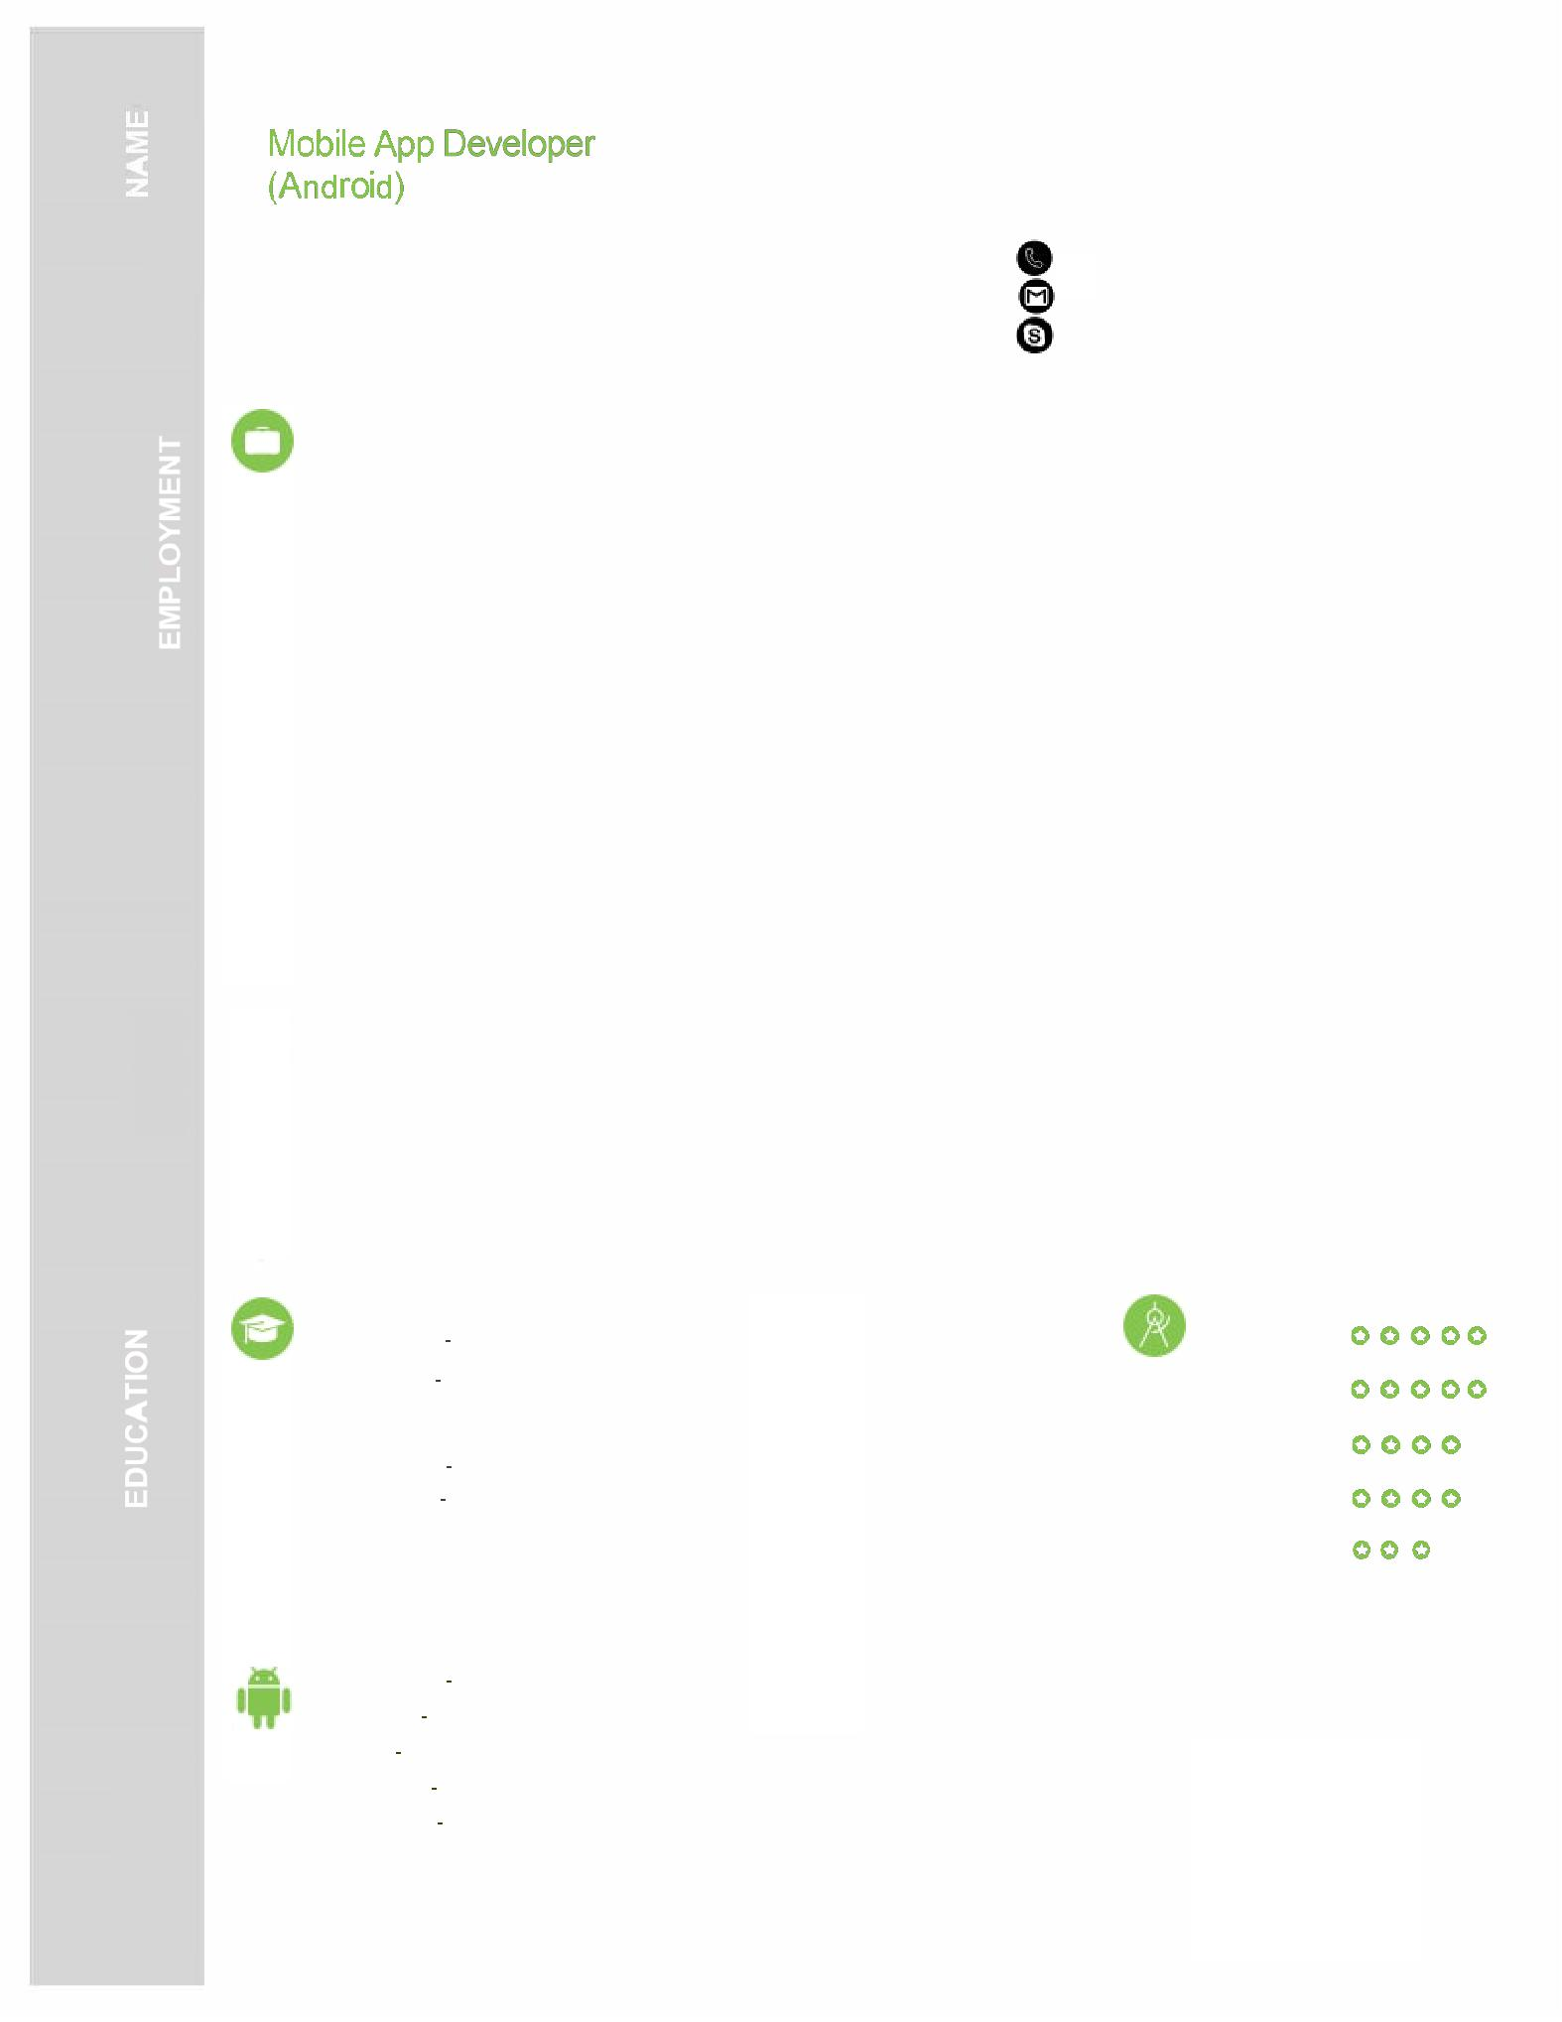
Roshan

Roshan.383913@2freemail.com

Present

07.2017

Ducem Technologies Pvt Ltd. 108, Someshwara Square, Vesu, Surat 395007 Gujarat

Android App Developer

Development, Research, Api integration, App store uploading Prototype Design

- Completed bespoke Android work for various clients including: development enterprise apps (Hitech Boards , Service Desk System, Paywell, Steel Crete, VCare, Katalyst, Lead

Tracking, Ushop) - Pursued Android SDK, Eclipse, Android Studio, SQL Lite, Java, XML, Rest, Soap, GCM, Google Analytics, Picasso

01.2017
06.2017

09.2015
12.2016

Bphoenix Business Solution 108, Someshwara Square, Vesu, Surat 395007 Gujarat

Android App Developer

Development, Prototype Design, Research, Api integration, App store uploading

- Completed bespoke Android work for various clients including: development enterprise apps (Hitech Boards, Service Desk System, Paywell, Steel Crete, VCare, Katalyst, Lead Tracking, Ushop) - Pursued Android SDK, Eclipse, Android Studio, SQL Lite, Java, XML, Rest, Soap, GCM, Google Analytics, Picasso

Tech-Fusion Technologies C-7/8 Dhir Construction, Opp. Samarpan Sadhak Nivas, Eru, Navsari 396445

Android App Developer

Development, General Testing

- Worked as fresher android developer for various local projects
- Pursued Android SDK, Eclipse, SQL Lite, Java, XML, Rest api.

Mahatma Gandhi Institute Of Technical Education and Research Centre Session 2011 to 2015 ( With Performance (6.11 CGPA)

Degree B.E (Computer Sci, And Engineering)

Vallabhbudhi Polytechnic

Session 2007 to 2010 ( With Performance (71% )

Degree Diploma (Diploma in Computer Sci, And Engineering)

Java

Android

C, C++

SQL Database

Api Integration

