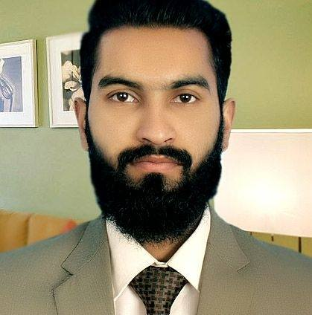
ABDUL

E-mail: abdul.383934@2freemail.com

SUMMARY

- Qualification: Intermediate from Govt. islamia college, Civil Lines Lahore.
- More than one year of Experience in Graphic Designing at ioSol IT Solutions (Pvt)LTD.
- 10 month Experience in Digital Marketing at Server97 (Pvt)LTD.
- Interested domain to work Graphic Designing.

Professional Skills

- Adobe Photoshop
- Adobe illustrator
- Adobe indesign
- Adobe Premiere Pro
- Adobe After Effects
- 3Ds Max
- Digital Marketing (SEO, SMO, SEM)
- Wordpress

PROFESSIONAL EXPERIENCE

ioSol IT Solutions (Pvt)LTD.

Designation: Graphic Designer
Period of employment: December 2016 to September 2018
Responsibilities Include:

- Develop attractive designs and graphics, logos, icons, Banners, Gif etc.
- Expertise in illustrator and Photoshop.
- Main expertise in the field of logos, banners, vector tracing etc.
- Develop creative design for E-commerce Websites and Social Media.
- Video editing by using software Adobe Premiere Pro.
- Develop motion graphics by using software programs, such as Adobe Photoshop and
Adobe After Effects.
- I must also have the ability to work collaboratively within a disciplinary environment.
- Implementing and improving call to action features using creative designing ideas.
- Up to date with industry leading software and technologies (Adobe Photoshop, Adobe Illustrator, Adobe InDesign, Adobe Premiere Pro, Adobe After Effects, 3Ds Max etc.)
- Website content, Graphics and icon update on Wordpress.

Server97 (Pvt)LTD.

Designation: Digital Marketer
Period of employment: January 2016 to December 2016
Responsibilities Include:

- Working on On-Page and Off-Page SEO Techniques.
- SEO/SMO responsibility, doing all promotion of Facebook and SEO.
- Paid campaigns of Facebook and Google AdWords (CPC).
- Indexing websites in search engine and reported about Google analytics.
- Social book marketing, ad posting.
- Measuring and reporting on the performance of all digital marketing campaigns.

EDUCATION

- Intermediate in Computer Sciences in 2013
Islamia College Civil Lines, Lahore, Pakistan

PERSONAL INFORMATION

Date of Birth: 29 September 1994
Nationality: Pakistani
Marital Status: Single
Visa Type: Visit Visa
Activities: Gaming, Internet Suffering, Attend informational Events, Fitness, Songs.

REFERENCES

- Available on request

