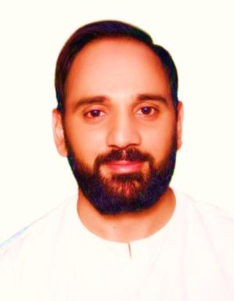
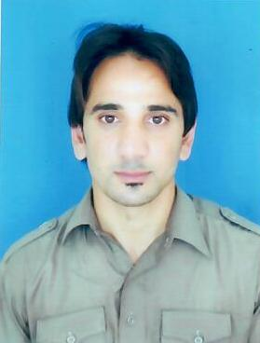

Email: Mufasser.383936@2freemail.com
Career Objective

To acquire a challenging career with a well reputed company utilizing the opportunity to offer proven and developing skills within the company.

Education

Educational Details:
Year | Full Name of Institution | Degree | Title of degree
2014 | HAZARA University Mansehra | B.B.A (Hons.) | Bachelor in business administration Four year program.
2012 | Government Degree collage No 1 Abbottabad | FSC | Higher Secondary Education.
2010 | Government High School No 3 Abbottabad | Matric | Matriculation.

Previous Employment
Company | Ravi Exchange Company Pvt.Ltd
Exact Title of Position held: | Branch Manager
Duration: | August-2015 TO Dec 30-2016
Name and title of boss): | Sheikh Umer
Address of employer: | Islamabad Pakistan

Brief description of duties and responsibilities:
- Maintaining cash
- Selling and buying foreign currency
- Booking TT
- Sending and Receiving Money
- Book keeping and record keeping of the invoices
- Booking Demand draft
- Final report of daily sales
- Quarterly and annually financial report
- Recording Daily Transaction
- Maintaining and managing confidential records.

Responsibilities as Branch Manager
- Look after of Branch
- Keep updating Record of Branch
- observing the employees work and motivating them accordingly
- listening to the employees queries and forwarding to the Head North for the positive result

Previous Employment
Company | MCB Bank Pakistan
Exact Title of Position held: | Cashier
Duration: | July 2014 to Feb. 2015
Name of Branch Manager | Nouman Ali
Address of employer: | Muzaffarabad AJK

Brief description of duties and responsibilities:
- Maintaining cash
- Receiving and Distributing cash

Computer Skills:
- MS-office, MS-excel, MS-power point.
- Searching Forex Rates
- Operating system (windows 98, windows xp, windows vista, windows seven and eight).
- Hard ware installation
- Accounting softwares ( WUPOS & FMS )
Personal Competences
- Ability to work in a fast-paced environment to set deadlines.
- Believe in Team work
- Enthusiastic self-starter who contributes well to the team.
- Highly flexible to the environment
- Hard worker & truthful

PERSONAL DETAILS:
Nationality: Pakistani
Date of Birth: 02-03-1992
Marital Status: Single
Languages: English, Urdu, Hindi

Hobbies & Activities
Reading books and Novels
Playing Cricket & Football
Social Media
Cooking .

References
Would be furnished upon Request

