arun
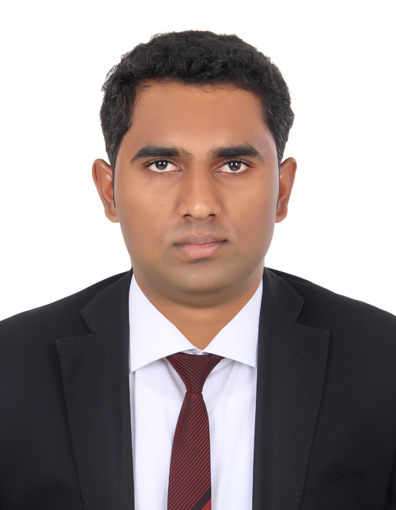
MECHANICAL ENGINEER

VISA STATUS: VISIT VISA

arun.383942@2freemail.com

An enthusiastic and self-motivated professional seeking to establish in an organisation that enhances my professional abilities and helps me grow along with the growth of the organisation

CORE COMPETENCIES

MECHANICAL ENGINEERING

Level II Quality Control Engineer in UT, RT, RTFI, PT and MT with ASNT certifications (2016)

Certified Quality Controller in accordance with standards and guidelines of API, BS, ASNT, ANSI, ASME and ISO

Advanced Training in CAD/CAM & On the Job Training of Machine Operations & Industrial Engineering Applications, completed at STEEL AND INDUSTRIAL FORGINGS (KERALA) certified by COCHIN UNIVERSITY OF SCIENCE AND TECHNOLOGY (2018)

ACADEMICS

Completed Skill Acquisition For Engineers (SAFE) from Steel & Industrial Forgings Ltd., Athani, Thrissur, Dept of Industries, Govt. of Kerala, under Cochin University of Science & Technology, Kerala with 82%(06/05/2018)

Completed B.Tech in Mechanical Engineering from University of Calicut with a CGPA of 6.84 {68.4%} (2015)

Higher Secondary Education under CBSE with 72% (2011)

Secondary Education under ICSE with 79% (2009)

Technical Highlights

- Industrial visit to INSTRUMENTATION LIMITED, PALAKKAD.
- Industrial visit to BHARAT EARTH MOVERS LIMITED, PALAKKAD
- Industrial visit to FLUID CONTROL RESEARCH INSTITUTE, PALAKKAD
- Industrial visit to HYUNDAI MOTORS INDIA, CHENNAI
- Attended 3 day workshop “AUTOFACTORY REDEFINED” by SOCIETY OF AUTOMOTIVE ENGINEERS (SAE)
- Manufactured F1 car model from scrap (Frame Work and Chassis)

PROJECTS and SEMINAR

Title: Design and Fabriccation of Small Scale Sugar Cane Harvester
Synopsis: Design was created and a prototype was manufactured which was economic and also convenient to use

Title: Design and Fabrication of Water Cooling System for Solar panels
Synopsis: Solar panels were provided with a water cooling system which resulted in the improvement of efficiency by 3% and also an increase in the life of the panel

Title: Seminar on “Cryogenic Treatment of Brake Rotors”
Synopsis: The seminar was about subjecting the brake rotors to a cryogenic treatment prior to the normal manufacturing processes which will elevate the efficiency and life of the rotor

EXTRACURRICULAR ACTIVITIES

- Inter school participation in Quiz Competitions
- Inter school participation in elocution competitions
- Member of college badminton team
- Member of college cricket team

SKILL SET

- MASTER CAM Designing & CNC Programming
- Ultrasonic Testing (Doppler, Einstein and Digiscan), Magnetic Particle Testing, Penetrant Testing, Radiographic Testing and Film Interpretation, ISO 9001: 2008
- Quality Management Systems (QMS)
- MS Office
- Solid Works
- Solid Edge ST5
- NX 9

PERSONAL DETAILS

Date of Birth : 03-Feb-1993
Languages Known : English, Hindi, Tamil and Malayalam.

