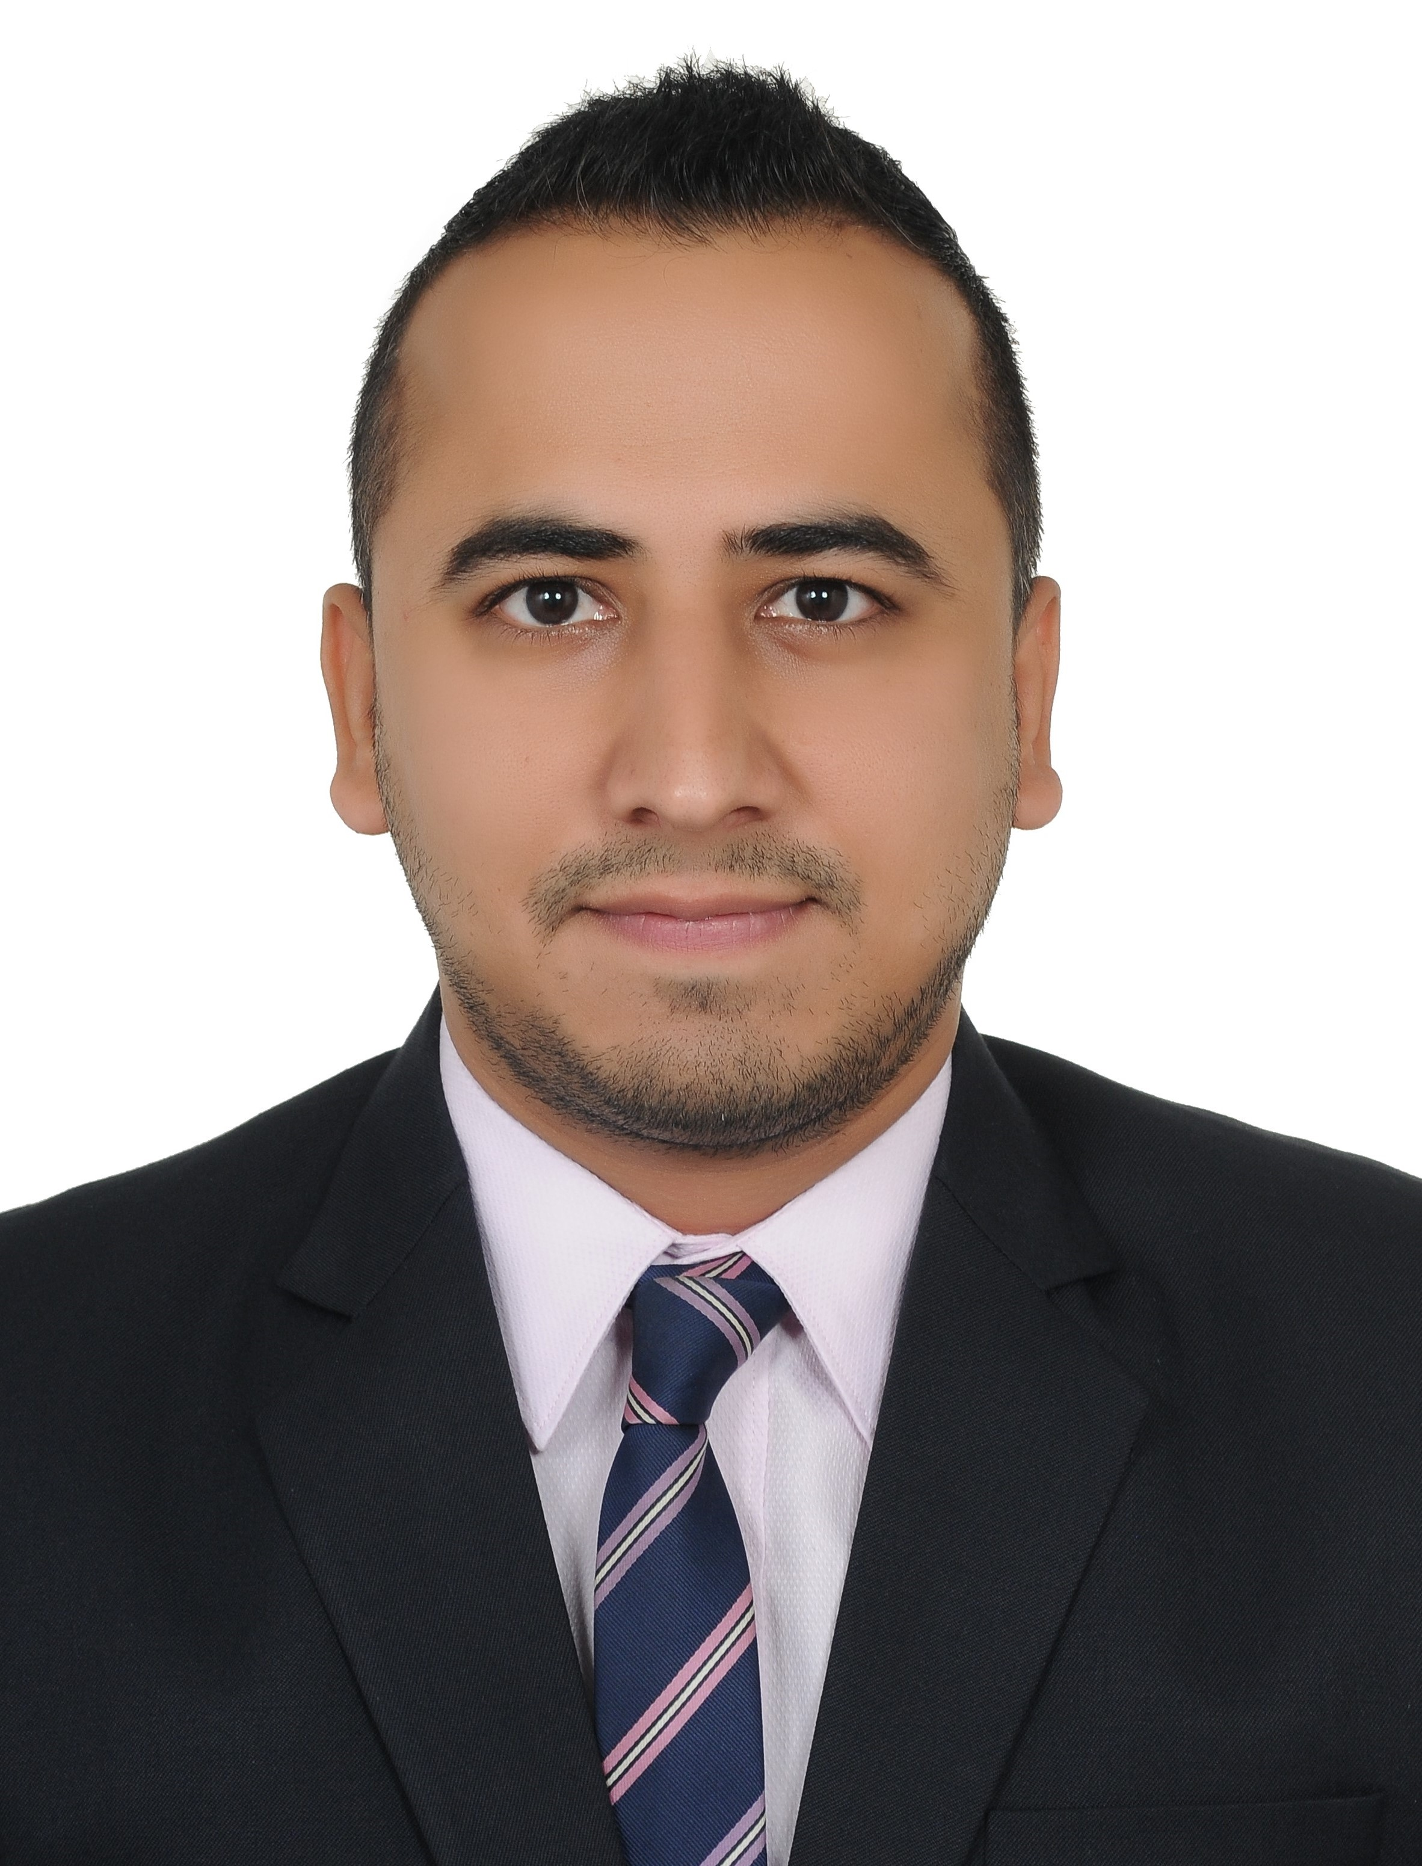
Amit
DOB: 9th July 1988
Email: amit.383960@2freemail.com
Nationality: Indian

ProfileSnapshot
MBAfromChetana’s Institute Mumbaiwith5+yearsofexperienceinvariousverticals(Business,Strategy,Sales&Operations)andindustry(Banking,E-commerce& Digital Marketing),currentlyworkingasaSales ConsultantatLunad Media & Communication LLCinDubai

ProfessionalExperience
Sales Consultant,Lunad Media & Communication LLC(Digital Advertising) Feb’17 –Present
Responsibilities | - Managing and growing key accounts revenue across Yellow Pages Portfolio on online media  - Researching, identifying, approaching and converting new clients into business by consultative selling approach  - Managing clients email campaigns and helping to communicate their brands through email marketing  - Achieve continuous profitable results by managing an extensive client base, delivering top line revenue growth and creating innovative solutions across online media  - Create and nourish business relationships by providing digital & online industry knowledge and high standard of customer service to facilitate growth and return on investment with clients  - Developing brand awareness & market penetration of Yellow Pages Portfolio through participation in trade exhibitions and B to B events  - Supporting higher management with a comprehensive reporting system that facilitates in accurate sales forecasting
Business DevelopmentManager,Credr.com (E-commerce) April’15 –Nov’16
Business | - HeadingBombayteamof20resources,managingallCityverticalslikeBusinessdevelopment,Operations,Post sales services, Payments, Marketing and Admin  - Expanded Bombay region and added Thane, Ulhasnagar, Bhiwandi, Vasai and Navi Mumbaizone  - Increased bike inventory on website approx. 70% and bike sourced through Second Hand dealers by90%  - Developed a supply channel through OEM tie-ups and service network ties ups to increasesupply
Strategy | - Developed a milestone structure/Incentive plan for Second Hand dealers to pushsales  - Developed a Service Level Agreement (SLA) for Oct – Dec Quarter for our Businesspartners  - Focus of SLA was profitability as we rolled out a new (first ever) commission structure in themarket  - Dealer wise targets were developed for sales, inventory management, App usage& branding  - Achieved 100% adoption for our top dealers giving us 80% of the total sales inBombay  - Developed a SLA 2.0 for Jan-Mar quarter with additional focus on higher revenue generation andsales
Operations | - Decreased per inspector cost by 70% by developing a re-inspectionprocess  - Increased sales conversion efficiency from meeting conducted to bikes sold from 55% to89%  - StrategicallydecreasedperbikeincentivecostfromRs5000toRs500whileincreasingsaleswithdealers
Acquisition Manager, (Premier Banking/Corporate Salary), HDFC Bank Ltd, UdaipurApril’11 –March’15
Responsibilities | - Acquisition of new customers through HNI Segment for Liability Products (Savings/Current/Fixed Deposits) through Internal Database and Cold Calling  - Organizing Promotions & tie-ups for sourcing New To Bank HNI customers  - Coordinating with cross-functional verticals (Branch & Phone banking channels) for lead generation  - Understanding the offer/arrangement made to the Corporates by the Bank  - Penetrating every corporate relationship by signing up for additional salary accounts on an ongoing basis  - Ensuring that all accounts get salary credits and generate cross sales of various liability/assets products  - Handling a team of 5 CSE’s and responsible for achieving CSE productivity and number targets  - To coordinate with Service Branch RMs, Sales, Assets and other departments on an ongoing basis for new corporate acquisition
Summer Internship May’10 –July’10 Hindustan Times Media Ltd, Mumbai (2Months)
Project | - Institutional sales of MINT (Business daily) by targeting banks, hotels, B-schools  - Understood the functioning of print industry and expectations of business newspaper readers  - Studied the methodology by which newspapers are promoted and distributed to the target audience
AcademicProfile
PGDBM | 2009-11 | Chetana’s Institute of Management & Research, Mumbai | 74.26%
B.Com | 2006-09 | H R College of Commerce & Economics, Mumbai University | 79.85%
ClassXII | 2006 | Maharana Mewar Public School, Udaipur(CBSE) | 78.80%
ClassX | 2004 | Maharana Mewar Public School, Udaipur(CBSE) | 77.20%
Achievements
- Awarded Gold Medal for being the topper in academics for Marketing specialization
- Represented my School (2 Times) at District Level in Table Tennis Championship
- Attained the level of “Able Cadet” at NCC

