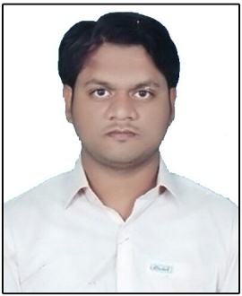
CURRICULUM VITAE

Tariq

Tariq.383968@2freemail.com

OBJECTIVE

To seek a challenging post in oriented organization with devoted to contribute positively towards its objective to the best my knowledge, abilities, skills and to serve with honestly, integrity and diligence with the firm believe that the entity’s would be my own.

EXPERIENCE

- Worked with Ghazi Security Guard Company in the capacity of Security Gaurd for the period from 2015 to 2016
- Worked with Soneri Bank in the capacity of Sale Executivein the year of 2017

ACADEMIC QUALIFICATION

- Matriculationfrom Board of Secondary Education Hyderabad in 2010.
- Intermediate from Board of Intermediate Education Hyderabad in 2013.
- Graduation from University Of Sindh in 2015.

COMPUTER SKILLS

- 1 Year Diploma In Information Technology (DIT)
- Office Automation (MS-Office)

PROFESSIONAL SKILLS

- Convincing communication and interpersonal skills.
- Positive & quick decision making.
- Sharp observation.
- Grip over labor and petty contractors.
- Understanding client needs.
- Self motivated and success oriented.
- Ability to works closely with other team members and departments.

PERSONAL INFORMATION

- Date of Birth : 05-09-1990
- Nationality : Pakistani
- Religion : Islam
- Marital Status : Married
- Visa Status : Visit Visa

