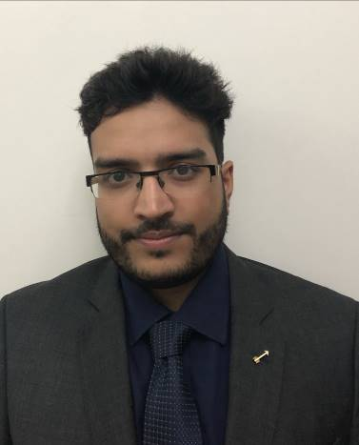  PERSONAL INFORMATION  Date of Birth: Dec 14th ‘90.  Nationality: Indian  Driving License: India  Marital Status: Single  Visa Status: Visiting Visa  QUALIFICATIONS  Bachelor of Engineering:  Computer Science  (2012)  Masters in computer science:  Information Security and Software Development  (Pursuing)  COMPUTER SKILLS  HTML5, CSS3, JavaScript, Python, SQL, Java, C, C++, XML, Windows Server, Linux, Adobe Creative Suite, Microsoft Office, PowerShell, Oracle, Wireshark, Amazon Web Services, Microsoft Azure. | Neilston  Email: neilston.383981@2freemail.com  Address: Dubai, UAE  CAREER EXPERIENCE  Southern Wood Packers, IND  Systems Administrator  February 2017 – July 2018  Skills & Tools: Windows Server, Linux, Oracle, PowerShell, Wireshark  - Helped troubleshoot network problems between the office and production machines.  - Created a database system for faster processing of orders.  - Created PowerShell scripts to help with day to day management of Active Directory and Exchange inboxes.  - Implemented new security protocols including forcing password standards for company users.  - Rebuilt new hardware and reconfigured hardware, peripherals, settings and directories according to standards and operational requirements.  - Update system software’s such as operating systems, database and antiviruses.  - Implemented more frequent backups to increase environment security.  - Managed servers, workstations, computers, laptops, printers, routers, switches and existing network applications.  - Reviewed server and application logs.
STRENGTHS  I am keen to build on my skills and experience, and love working in an energetic fast paced environment. I take pride in my attention to detail and ability to effectively manage my time. Able to work autonomously or as part of a team, with excellent organizational abilities. Always keep myself up to date with the latest technology and best practices. I am also very decisive in my actions and take full responsibility for them.  LANGUAGES  English, Hindi, Kannada & Konkani  ADDITIONAL INFO  Organized multiple events during engineering for inter collegiate festivals.  Volunteered to take care of disabled individuals at Cerebral Palsy Alliance Australia.  Runner-up for the State level Swimming Competition |  | Deepend Technologies, AUS  Frontend Web Developer  December 2015 – November 2016  Skills & Tools: HTML, CSS, JavaScript, SQL, XML  - Developed dynamic and interactive website that ensured high traffic, page views, and User Experience.  - Designed and developed user-friendly website, including optimized check-out page that increased user clicks.  - Oversaw full life-cycle of software development for 3 projects with 100% on time delivery  - Designed processes for clean-up and performance improvement, that minimized downtime by 13%.  - Fixed bugs from existing websites and implemented enhancements that significantly improved web functionality and speed.  Masterpiece Originative, AUS  Frontend Web Developer  February 2015 – November 2015  Skills & Tools: HTML, CSS, JavaScript, Google Analytics  - Designed and developed GUI for applications and modules, using JavaScript.  - Built single-page applications with JavaScript on a custom-built framework.  - Tested front-end code in multiple browsers to ensure cross-browser compatibility.  - Translated design team’s UX wireframes and mock-ups into responsive, interactive features, using HTML/CSS and JavaScript.  - Updating Content Management System (WordPress, custom CMS)  - Creating new WordPress themes from HTML design  - Monitoring Google analytics.

