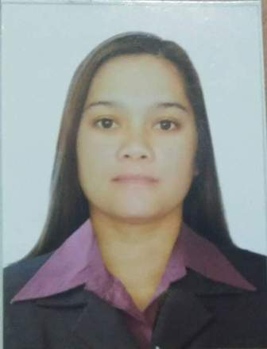
AIZA

Aiza.384027@2freemail.com

OBJECTIVES:

- To obtain a position of responsibilities that utilizes my skills and experience and keen to work in an environment where I can enrich my knowledge.

SKILLS AND QUALIFICATIONS:

- Operate, regulate, process and understand data using software applications.
- Resourceful team player who excels at building trusting relationships with customers.

EDUCATIONAL BACKGROUND:

Tertiary : METROPOLITAN COLLEGE OF SCIENCE AND
TECHNOLOGY
2 year - Computer Science
Santiago City, Isabela, Philippines
2008-2009

Secondary : DONA JOSEFA EDRALIN MARCOS HIGH SCHOOL
Ilut, Cordon, Isabela, Philippines

Elementary : ANONANG ELEMENTARY SCHOOL
Cordon, Isabela, Philippines

IT SKILLS:
Proficient in Microsoft Office Suite (Word, Excel)

EMPLOYMENT HISTORY:

Data Encoder
CITY XPLORE.NET CAFÉ
2009-2011

- Duties require encoding of application and taking biometrics of passport application.
- In charge of verifying, cashiering and sending passport applications.
- Duties also require answering the phone, releasing passports and sending out documents through mails.

Merchandising
PRIMARK SAVEMORE
2008-2010

- Promote and market food products via store displays.
- Use visual techniques to attract customers to their food products.
- Assist with billing and pricing of food products and client food orders.
- Take inventory, removing expired/damaged products, replacing products.
- Meet with store managers on re-ordering products.

AMIGOS RESTAURANT
PRIMARK SAVEMORE
2012-2013

- They greet customers, take food orders, bring food and drinks to the tables and take payment and make change. ... Make no mistake, being a waiter or waitress is hard work.

PERSONAL DETAILS:

Nationality : Filipino
Date of Birth : February 4, 1988
Marital Status : Married
Languages : English, Tagalog
Reference : Available upon request

I hereby certify that the above information is true and correct to the best of my knowledge and belief.

AIZA
Applicant

