Sandeep
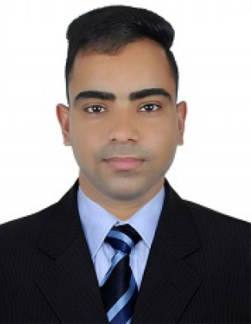

Sandeep.384036@2freemail.com

Personal statement

An experienced and competent IT Support technician with 5 + years’ experience in a variety of office-based environments. A level head and rational approach to problem solving leads to reliability and fast solutions to IT technical issues. Ability to explain procedures in a practical and user friendly way means that many IT problems can be solved via the telephone.

Core skills

- Vast experience in IT problems and solutions
- Fully experienced in providing and maintaining IT security across large networks
- Workload and time management
- Experienced and trained in Microsoft Office
- Broad knowledge and experience of all IT operating systems
- Experienced and able to work in shifts and night duty
- High learning capacity and troubleshooting skills
- Handle multitasks calmly and efficiently
- Highly skilled in verbal and written communication

Highlights

- More than three years’ experience working with ‘Opera and Micros HospitalityManagement System’
- Experienced in Aruba Network and virtual controller for ‘Aruba Access Points’.
- Experienced in HP Pro Curve Network and Switch Management.
- Experienced in maintenance of ‘IPTV System’.
- Experienced in maintenance of Vingcard Door Lock System.
- Fully trained in IPTV system including Screen Mirroring, and VOD.

Employment history

IT Support
Melia Desert Palm Resort and Hotel, Dubai, UAE
(September 2015 – present)
Duties
- Being first point of call for all IT issues
- Maintaining Opera Hospitality Management System Server including user’s installation and troubleshooting
- Maintain Micros 3700 POS in six outlets including thermal and kitchen printers
- Forward major issues for Opera and Micros with Opera support team and get fixed in urgent
- Maintaining SPA Connect for Samana spa including user’s installation and troubleshooting
- Maintain Guest Wi-Fi, Music System and IPTV system in guest Rooms and Villas.
- Respond Quickly for any kind of guest complaints for Guest entertainment facilities.
- Maintain all Desktop and Laptop in hotel for operational use, including hardware and software troubleshooting
- Maintain domain server and domain users with security credentials and maintain NAS data server for operational staff.
- Manage IPTV network and Palvision IPTV system for Guest Rooms, Bar and Gym
- Manage Vingcard Door Lock Network (Hardware and Server) including VISIONLINE key Card system for Access Control
- Ensuring that all SQL and Oracle Database backup is done on Daily, Weekly and monthly Bases
- Maintain Wi-Fi, Projectors and Signage for Banquet Halls, and provide Wi-Fi for outside events and help banquet team for AV system.

IT Support Technician
Ritu Wears by JDS apparels, Punjab, India
(June 2013 – July 2015)
Duties
- Managing the IT help desk and providing instant solutions for IT issues
- Managing Ginesys Retail management software for all the POS and following technical issues with Head office
- Properly maintain and troubleshoot for all the POS and Backofficesystem
- Maintained CCTV in mall with digital video recorder
- Maintain attendance system for HR
- Running diagnostic checks and servicing essential IT hardware
- Explaining complex IT issues to non-technical employees
- Identifying and solving IT problems and logging them into the relevant databases
IT Support Assistant
Karan Infotech, Punjab India
(October 2011 – May2013)
Duties
- Installing new systems for Business and home users
- Providing Quick IT support for clients on their location
- Assemble new computers for the clients, doing all kind of software installation and hardware troubleshooting.
- Repairing and upgrading hardware for computers and CCTV system
- Install new CCTV cameras and maintain Recording system
- Maintain all inventory in show room and dealing with customers to sell new systems
- Providing proper IT solution for clients and assemble computers according to their requirements

Education

Abacus Institute of hardware and Technology
(2010 – 2011)
1-year diploma in computer hardware and networking
Punjab University
(2011 – 2014)
Bachelor in Arts (3years)

Punjab School Education Board
Secondary School Education (2008)
High School Education (2006)

Personal Information
Date of birth : 23-10-1990
Marital status : Single
Nationality : Indian
Height : 5’10”
Language : English, Punjabi, Hindi

