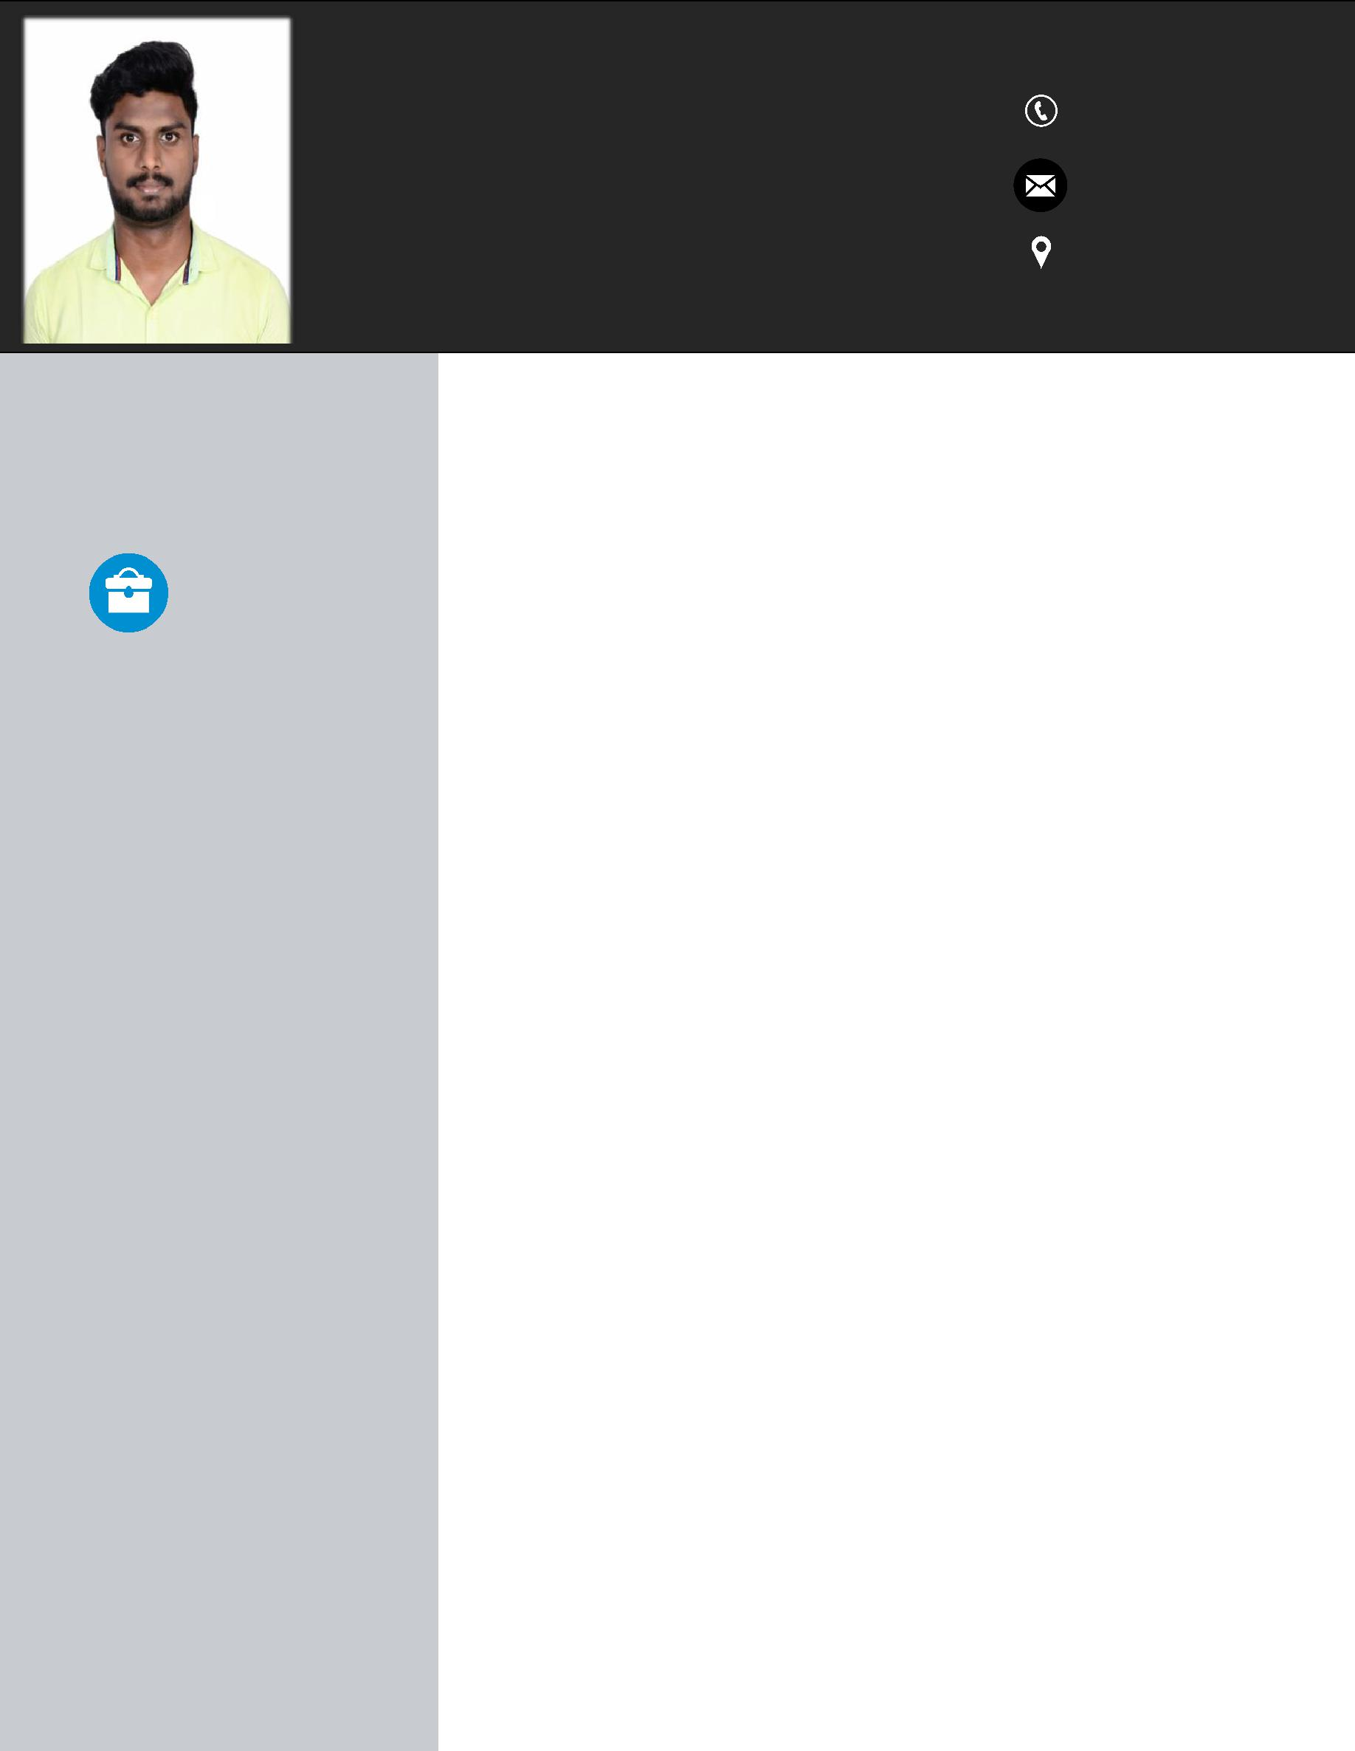

Ibrahim

BUSINESS DEVELOPMENT – IT

SERVICES AND PRODUCTS

Ibrahim.384053@2freemail.com

.

EXPERIENCE

AXL Techno Systems

April 2017 – July 2018

PROFILE SNAPSHOT:

Sales professional with more than 3 year of experience in cold calling, strategic selling, market research, Lead generation and identifying new geographies with demonstrated history of working in the information technology & services industry.

Executive – Senior Business Development

- Manage full life cycle of the sales process from prospecting to closure of account through cold calling.

- Responsible for end to end sales cycle from Qualification to closure and Win/Loss Analysis

- Responsible for end to end Proposal preparation - RFP’s with specific deadlines.

- Preparing response to RFP/ RFI on the requirements received from the prospects on various Infrastructure & Cloud modules

- End to end services covering implementation, support, up gradation and customizations for Infrastructure Management software such as ScienceLogic,

SolarWinds, ConnectWise etc…

- Wide range of business solution across domains and vertical from IT infrastructure.

- Interacting with Subject Matter Experts (SME) and Infrastructure Solution Architects for preparing the response documents

- Anchoring customer calls for requirement gathering and service demonstrations

- Organizing internal teams to work on specific demo scripts, if any, given by the prospects

- Collaboration with OEM account executive for solution discussion and OEM product demonstration

- Creating functional/ business power point presentations for customer demonstrations

- Interacting with solution partners in the case of a consortium, frequently following-up for product and other corporate information to prepare the RFP response

- Interacting with internal stakeholder to customize MSA if requested by client.

KRYPTOS

TECHNOLOGIES

May 2016–Apr 2017

Executive – Lead Generation

- Generating leads and making calls from the US region.
- Determine client requirements and expectations.

- Responsible for creating prospective clients by taking first-level calls, identifying opportunities and qualifying the business opportunity in US Market

- Identifying Key Decision Makers(C-Level & V-Level, Directors) people from Global 2000 and SME companies in US.

- Performing secondary research activities including company profile analysis, industry analysis with right prospect / client information

- Touch- base with potential customers, Opportunity sizing and further taking to the next level of discussion.

- Account management- work on existing account to get new business.

- Follow up for commercial discussion to close the deal, once the technical discussion is over.

- Responsible for managing, marketing and promoting the service we provide through, all social media pages.

- Worked with subject matter experts to draft and manage the process of statement of work and contract creation and responsible to receive sign off from customer.

WORLDNXT

INFOMEDIA PVT LTD

Feb 2015–Apr 2016

EDUCATION

Executive – Lead Generation

- Primary sourcing analyst and quality analyst

- Independent Lead Generation, Value proposition positioning, warm handovers to sales team

- Data profiling, verifying email and email campaign.

- Seeking out and identifying new business opportunities.

- Develops sales opportunity and assists in developing the pipeline for future sales activity through daily interactions with customers.

B.E. (Electronics and |  | Thangavelu Engineering College
Instrumentation) |  | Anna University
2010 - 2014 |  | 6.5 (CGPA scale: 10)
Higher Secondary |  | JGN National Higher Secondary School
2008 - 2010 | 74%
Secondary School
2008 | 86%

SKILLS

Technical Skill Set

INTERPERSONAL SKILLS

- CRM: Microsoft Dynamics CRM, ZOHO CRM, BPM Online.
- Office Tools MS Utilities, SharePoint.

- Business Development: Cold Calling Persistent Follow ups and Lead Generation through various medium. ( ZoomInfo, LinkedIn, Career Portal etc..)

- Felicitated and Closed deals in current organization.

- 2 Deals closed worth - $75,000 (SharePoint Migration and RIM monitoring support)

- Built revenue pipeline of USD 250,000 in a span of 6 months

- Always determined and possess “Never give up” attitude.
- Intense passion to deliver the best customer satisfaction service.

- Being innovative and sharing the best practices across teams to enhance consistency in performance.

- Good Analytical and problem solving skills.

- Collaborating with all cross functional teams within organization by extending the best support in achieving results.

- Self-motivated and possess tendency to resolve escalation/problems without the interference of supervisor.

- Effective communicator and presenter.

- Ability to understand new process/techniques and to effectively transfer the knowledge obtained to team members.

- Negotiating with customers on key parameters that profits the segment wise business of the organization.

•
• | Date of Birth | : October 19, 1992
• | Gender | : Male
• | Mother Tongue | : Tamil
• | Language Known | : English, Tamil.
• | Hobbies | : Travelling, Watching movies, Playing tennis ball
 |  | cricket.

