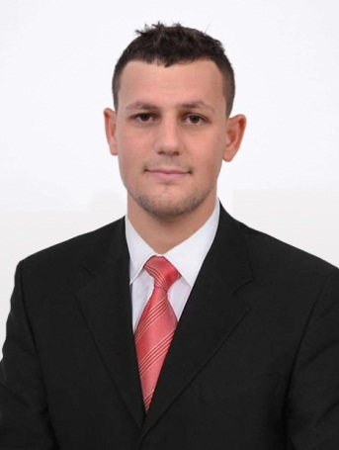
Slimane

E-mail: slimane.384112@2freemail.com

Visa :Tourist/ Single - long

Marital Status : Single

Process engineer

EDUCATION/ QUALIFICATIONS

Institute of Maintenance and Industrial Safety
Duration: (09/2011- 07/2016)
- Master’s degree: Petrochemical Industries(2014-2016)
Major: Petrochemistry
- Bachelor degree: Process engineering(2011/2014)
Major: Petrochemistry/ Process
Baccalaureate (06/2011)
Series : Experimental Sciences
Average: 14,51/20 Mention : With honors

Professional Qualifications
ESTABLISHMENT: British Safety Services (12/2016)
- HSE Supervisordiploma
- Fire Fighting Training
- First Aid Training
ESTABLISHMENT : The International Red Cross and Red Crescent Movement - Algeria(06/03/2016- 14/03/2016)
- First Aid Training
ESTABLISHMENT: Intensive Language Teaching Centre(02/2016 - 05/2016)
- English Training
EXPERIENCE

- Oil and gas Group (ANADARKO JV SONATRACH)
- Title job: Production Technician Duration:August 2014 - August 2016

- Wellhead: (gas, oil and water producer, gas and water injector).
- The surface equipment (valves, chokes, safety valves, flow lines).
- Manifold wells: (gas / oil / water).
- Chemical and freshwater injection pumps.
- Experience in technical support (optimization, Procedures, investigations).
- Assisting all field operations with highly Professional supervisors.
- Control room operations DCS.
- Control of chemical injection.
- Laboratory operator: laboratory analytical experience in hydrocarbon testing.
- Process operator : to take care of the good working of the station (better separation of the crude element oil,water and gas , to take care of the wells gauging and their performances….etc).
- Prepare Daily report.
- Check the HSE standards in wells area.
- Easy handling on the control panel of safety valves.
- Good interpersonal skills, ability to work as a team member or allow.

- SARL SI LHADJ LAMOURI- Gas Station Project
- Title job: HSE Supervisor Duration: January 2018 – July 2018
- Ensuring compliance with all HSE measures and ensuring campany’s objectives are met.
- Implement risk assessment and conrols on site activities.
- Report and investigate accidents, near misses, damages, lose of environment , develop and implement preventive actions.
- Supervise the operation , lifting excavation work , working at height….. etc.
- Inspection of all safety equipment including slings and fire extinguishers, safety harnesses…etc.
- Carry out inspections in the field of Health and Hygiene.
- Preparation of the weekly and monthly report.

- Activity LRP- Division LQS - Complex of GL1.Z/ Oran
- Title job: Trainee Duration: March 2016 – April 2016
- I did a practical internship in this society in order to know the principal steps to liquify natural gas .
- Society of Division refining- Refinery of Arzew- Oran
- Title job: Trainee Duration: March 2014 – April 2014
- I did a practical internship in this refinery in order to understand, to see all the steps to treat petroluem to get petrole,gasoil,kerosene,…….,aspalt.
- Society of Branch GPL - DISTRICT GPL TIARET
- Title job: TraineeDuration: August 2013 – August 2013
- I did a practical internship in this establishement in order to know how to distribute the derivates of petroluem to gas stations of this state.

SKILLS
Languages&level :Computer Skills:
Arabic: NativeMicrosoft office( Word, Excel, Power point)
English: Excellent Hysys
French:ExcellentC++

ADDITIONAL INFORMATION

- Country of citizenship : Algeria
- Driving license : Category B / Algeria
- Date and place of birth:31/07/1992 in Ksar Chellala/ Algeria
- Person in charge: dynamic, ambitious, good personal and interpersonal,self motivated, fast learning, working under pressure, time management.
- Military Service: Regular

