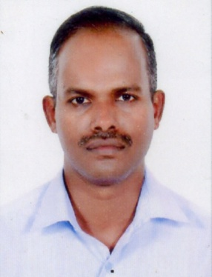
LALICHAN
Dubai, Deira

Email: lailchan.384159@2freemail.com

HEAVY DUTY DRIVER

OBJECTIVE

To attain the challenging posting in the related filed to work in an organization where I can enhance my skills and contribute to the growth of the origination as well as I assure you that I will work with full of my sincerity and do justice my job and the organization.

PERSONAL DETAILS

Name : Lalichan
Nationality : India
Date of birth : 10/05/1975
Visa Status : Employment Visa
Gender : Male
Religion : RC
Marital Status : Married

LICENSE DETAIL

ISSUE DATE : 30/08/2009
EXPIRY DATE : 29/08/2019
PERMITTED VEHICLE : Light Vehicle & Heavy Track Vehicle
PLACE OF ISSUE : Ras Al Khaima

EDUCATIONAL ATTAINMENT

- Higher Secondary
LANGUAGE

- English, Hindi, Malayalam

WORK EXPERIENCE

Totel Experience 10 Years

- 8 years Driving experience as Driver at Al Wadi General Trading L.L.C
in Ras Al Khaima (UAE)

- 15 Months Driving experience as a Driver at Bin Moosa & Daly LTD.L.LC in Sharjah (UAE)

KEY SKILLS AND COMPETENCIES

- Fully aware of all traffic regulations.
- Customer focused attitude and a friendly personality.
- Holding a current valid UAE license.
- Ability to read maps and follow verbal geographic directions to route changes.
- Having a confident and friendly personality
- Keeping the bus interior clean and safe for passengers.
- Keeping operational records and making simple reports.
- Assisting disabled passengers with baggage onto the bus.
- Reporting delays and accidents to controllers at head office.
- Checking a buses water, gas, oil and mechanical condition before driving
STRENGTHS

- Good communication skills
- Excellent attention to detail
- Ability to work independently and work in a team
- Able to respond quickly in emergency situation

REFERENCE

I hereby attested the accuracy of information declared above are true and correct the best my knowledge and belief.

Lalichan

