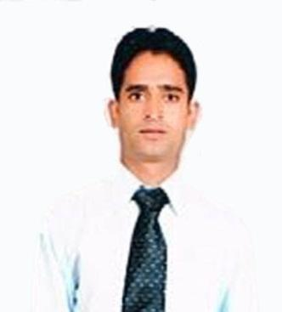
Mahipal

Mahipal.384184@2freemail.com

_____________________________________________________
_____________________________________________________

Objectives:

Seeking a responsible and challenging position in a growth orient progressive institution where my experience and skills will significantly contribute to overall success of the organization and provide opportunities for my career a growth.

KEYSKILLS:

- Perform efficiently under work pressure.

- Good in customer service skills.

- Wiling to learn other skills.

- Hardworking, loyal and honest.

Working Experience:

- ​Chinchaaus Restaurant​: As a seiner waiter from 1​^{st​}April 2014 to1st june 2018 in al karama dubai U.A.E.

- Terrace Garden Restaurant and Bar​​: ​Worked as a waiter from
10​ August 2010 to 13​ June 2012 in T.D.I.mall Rajouri garden new delhi india.
th ​ th​

❖ Hotel Tushar Elegant​: ​worked as a tr. waiter from 10​^{th​}March 2009 to 1​^{st​}July 2010 in Kavi Nagar Ghaziabad India.

Duties and Responsibilities:

- Welcome and acknowledge all guests according to company standards.

- Escorts customers to their table and ensure they are settled comfortably.

- Takes orders from customers for food and beverages, writes down or memorize the orders; and enters information into the computer for transmittal to the kitchen.

- Answer customer inquiries.

- Carry trays of food or drink from the kitchen to the dining tables.

- Serves food and beverages promptly.

- Collect the customers’ payments and prepares bills with itemized costs.

- Prepares and tidies up the table or counters; makes sure there are enough salt, sugar, pepper, cream, other condiments and napkins in every table or counter.

- Performs other duties like brewing coffee and preparation of salads and appetizers.

- Stays alert for customer’s requests and be prompt to address them.

- Perform other tasks assigned by supervisor or manager from time to time.
- Speak with others using clear and professional language.

- Develop and maintain positive working relationships with others, support team to reach common goals, and listen and respond appropriately to the concerns of other employees.

EDUCATIONAL BACKGROUND:

- Matriculation passed from U.K. Board.

- Hotel Management from ​Thihari Institute Of Management​​for year of 2012 to 2013.

- PIC Certified​​(program is an initiative by Dubai Municipality Food Control Department )

Personal Information:

Nationality | : | Indian
Date of Birth | : | 08/07/1988
Place of Birth | : | Uttarkhand, India
Marital Status | : | Married
Religion | : | Hindu
Languages | : | Hindi & English
Visa Status | : | visit visa

I hereby certify that the above given information is true and correct to the best of my knowledge and belief.

​ MAHIPAL

