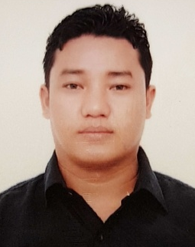
GOVINDA
Govinda.384185@2freemail.com

Bur Dubai, Dubai (UAE)

Career Objective
Seeking an opportunity to work with organization which enables me to enhance my skills in hospitality fields .Having a good experience in customer service and cashier, I would like to continue developing my skills on same field and learn from new and challenging positions. I consider myself a quick learner, hard worker, honest and adapt to new task with difficulties situations.

PERSONAL DETAILS:
- Date Of Birth : 10THDEC.1983
- Gender : MALE
- Religion : HINDU
- Marital status : Married

ACADEMIC QUALIFICATION:
Maha Laxmi Secondary school | 1st Division | 2003
Rehdoon Collage | 2nd Division | 2007

PERSONAL EXPERIENCE:
- WORKED WITH GRAND WESTEND (A UNIT OF JP GROUP OF HOTEL).

6 MONTH INDUSTRIAL TRAINNING.THEN I START TO WORK AS A TRAINEE WAITER FROM

2007 TILL 08/2008.
- CHECKING CLEANESS.
- STORE FOLLOW UP.
- DAILY INVENTERIES CUTLERY CROCORY LINEN AND ALL SERVICE EQUIPMENT.

- WORKED WITH MAINLAND CHINA AS A FLOOR SUPERVISIOR (A UNIT OF SPECIALITY RESTAURANT PVT.LTD).09/2008 TILL 05/2011.

- WORKED WITH SPAGHETTI KITCHEN/BISTRO 4U AS A FLOOR SUPERVISIOR (A UNIT OF PAN INDIA FOODS PVT. LTD).FROM 06/2011 TO 02/2014.

- PRESENTLY WORKING WITH IMPERFECTO AS A SHIFT MANAGER (A UNIT OF BEL CIBO HOSPITALITY).FROM 03/2014 TILL…

RESPONSIBILITIES

- FOLLOWING THE MOP.
- MAINTAIN THE ATTENDENCE REGISTER.
- MAKING PERSONAL RELATION WITH CUSTOMER.
- FOLLOWING THE HOLE RESTAURANT INVENTERY.
- FOLLOWING THE EXPIRY OF PRODUCTS.
- FOLLOWING THE SALE TARGET.
- CHECKING MRD.
- FOLLOWING FIFO.
- CHECKING GROOMING.
- FOLLOWING THE INVENTERY.
- FOLLOWING THE EVENTS.
- STAFF DUTY ASSIGNMENT.
- CHECKING MAIL ,FOLLOW STORE,CREATING DAY SPECIAL,MAKING CUSTOMER DATA BASE.

I hereby certify that all the above information are true and correct to my best of knowledge and behalf.

