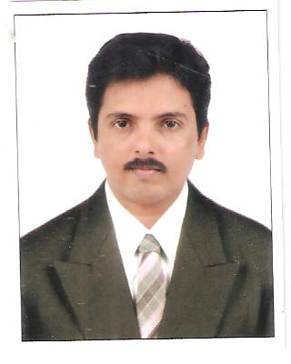

CURRICULUM VITAE

RAVICHANDRA
E-mail Id: ravichandra-384197@2freemail.com

---------------------------------------------------------------------------------------------
Objective
To make my career as a responsible and professional employee in an organisation that entrusts me to perform in challenging assignments that would in turn help the organization grow, and the experience of which will enable me to enhance my growth in a dyanamic environment that would require my aptitude and skills given an opportunity for my development.

EDUCATIONAL QUALIFICATIONS:-

Sl.no | Education | University/Board | Percentage
1 | S.S.L.C | KAR.SEC.EDU. Examination Board, Bangalore | 74.72%
2 | PUC | DepartmentofpreUniversity Education,  Bangalore | 73.16%
3 | B.COM | Mangalore University | 60.00%
4 | M.COM | K.S.O.U .Mysore | 55.58%

TECHNICAL QUALIFICATIONS:-

Sl.no | Course | Institution | Percentage/Class
1 | Diploma In Computer Application | AptechYuva Com, Managalore | First Class
2 | Junior English Typewriting | Chetana School of Commerce | First Class
OTHER SKILLS:-

Sl.no | Course | Institution | Percentage/class
1 | Spoken English Level | Institute of Retail Management, Belgaum | First Class
2 | Retail Level 1 | Institute of Retail management, Belgaum | First Class

WORK EXPERIENCE:-

Prakash Retail Pvt.Ltd :-

Working as a “Accountant” from January 2009 to May 2014
My key responsibilities are :-

- Dealing all the matters of Banks
- Coordination with customers
- Solving issue relating sale & purchase
- Negotiation with suppliers all the matter of purchase
- Maintain cash book, Bank book etc.
- Manage the A/C receivable and A/C payable of company
- Preparation of sales tax invoices and post of ledger.

Work experience in abroad (Oman)

- I have been working in a Furniture company for 5½ years as an Accountant cum Admin.

My key responsibilities are :-

- Maintaining accounts of customers account (debtors)
- Maintaining accounts of suppliers Account (creditors)
- Preparation of staff salary sheet & distribution of salary through cash & bank payments.
- Dealing all the matters of banks
- Inventory control
- Manage the A/C receivable and A/C Payable of Company.
- Preparing Trading, P& L accounts & B/S
- Supporting and caring customer.
- Maintain Bills and Managing Accounts.
- Maintain daily sales cash, petty cash etc.
- Preparing cash receipts and matching.
- Understand follow the quality policy.
- Issuing the cheque for the suppliers.
- Sending the monthly attendance report of the staff and workers to HO.
- Sending work report to HO on daily basis.
- Understanding a customer and solving problems with a verbal communication.
- Ordering the materials by issuing LPO (Local purchase) and OPO (Overseas Purchase).
- Taking responsibilities to work under pressure in solving the problems faced by the customer.
- Also, I have been handling maintenance works in our sponsors villas.

Computer Skills : MS Office, MS Excel, MS Power point, Tally ERP 9 etc.

TRAINING
Actively participated in Personal Rationale for effectiveperformance at Prakash Retail Private Ltd.(Harsha Electronics,one of the speciality show room) CERTFIED ISO-9001-2008 COMPANY at Udupi.

I also have passed (first class) in retail examination passed certificate received by Retail Mantra college at Belgaum

Personal Information :-
Gender : - Male
Date of Birth : - 02-10-1983
Languages Known :- English,Hindi& Kannada

Declaration :-

I hereby declare that the above mentioned information is correct up to my knowledge and I bear the responsibility for the correctness of the above mentioned particulars.

Place :Muscat
Date :- Ravichandra

