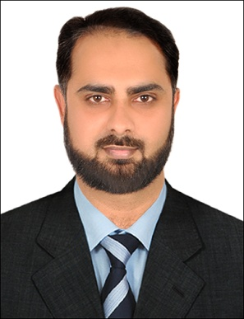
Date of birth: 30th April, 1979
Religion: Islam
Nationality: Pakistani
Marital Status: Married

FARAHAN
Email: farahan.384258@2freemail.com
WORK EXPERIENCE:
- HR Administrator
Al Shabbab Passenger Transport LLC
December, 2014 – September, 2018

- Human Resource Officer
AWARD (All Women Advancement
& Resource Development)
From March, 2012 To September, 2013

- HR Assistant / Date Validator
- BEFARe
- From 1stJune, 2011 to 31st December, 2011 &
- From 23rdSeptember, 2013 to 23rd November, 2013

- Admin & Finance Officer
K B Strengths (Procurement Solutions)
From October, 2008 to April, 2011
PROFILE:
- MBA - Finance & HR (Dual Specialization)
- 7 years of experience in various aspects of Administration & HRM.
- Successfully completed UNHCR & USAID projects.
- Provide senior management and others with various types of employee reports including attrition, absence, compensation, annual leave, overtime costs and headcount.
- Organizing the recruitment of staff, coordinating interviews & checking references.
- HR reporting to management.
- Managed time & attendance records for payroll
- Administering payroll/deductions/pensions for staff.
- Maintain management Information System (manual or computerized)
- Creative thinking
- Good Communication Skills
- Goal Oriented, Analytical Approach
- Strong-minded and a Team Worker
- Knowledge of Immigration Requirements (Visa Processing)

CERTIFICATION / ADDITIONAL SKILLS:
- MS Office (All versions, esp. MS Word, MS Power Point & MS Excel)
- Comrade
- ERP
- QuickBooks
- MIS (Management Information System)
- MCP (Microsoft Certified Professional)
- Oracle Developer 2000 Rel.6.0 & RDBMS

EDUCATION:
- 2008-2009: MBA (HRM: dual specialization) City University, Peshawar. 2.95 CGPA
- 2005-2007: MBA (Finance) City University,
Peshawar. 2.81 CGPA
- 1998-2000: B.Sc (Maths A, Maths B & Stats)
F.G Degree College for Men, Peshawar. 2nd Div

LANGUAGES:
- English
- Urdu / Hindi
- Arbic (Basic)

