HANEES RAHMAN. P
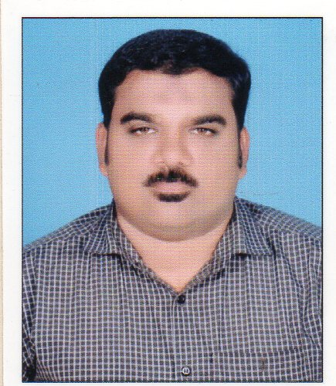
najapminha@gmail.com
Mob: 055 2526 870

Applied for the post of : Front Office / Reception

Address for
Communication:

PUNNAKKADAN HOUSE
EDAKKARA POST
MALAPPURAM DT.
KERALA STATE
INDIA
PIN: 679331

Personal Information:-

Date of Birth : 20/04/1975
Sex : Male
Religion : Islam
Nationality : Indian
Marital Status : Married

Passport Details:-

Passport No : N3367729
Date of Issue : 28/10/2015
Date of Expiry : 27/10/2025
Place of Issue : Malappuram

CAREER OBJECTIVE

To work in a congenial environment where I can utilize my knowledge and skill for the mutual benefit of self and organization, where I can derive the highest degree of job satisfaction, and my performance and ability will be highly appreciated.

PERSONAL SKILLS

- Effective Communication Skills (English, Malayalam, Hindi & Tamil)
- Excellent Service Skills, Disciplined and Goal Oriented
- Ability to interact with Senior level and people of diverse back ground
- Capable to handle busy environment.

TECHNICAL QUALIFICATION

- Diploma in Computer Application (D.C.A)
- (windows, Ms-Word, Ms-Excel, Power Point, Internet &E-mail etc…)
- Type Writing (English)
- K.G.T.E Lower & Higher from Govt. of Kerala

EDUCATIONAL QUALIFICATION

Graduate in Economics | University of Calicut
Pre-Degree | University of Calicut
S.S.L.C | Secondary Board of Kerala

EXPERIENCE IN INDIA:

EXPERIENCE IN ABROAD:

- Worked as a Data Entry Operator cum Typist in Orient Electricity Company Jeddah- K.S.A
Period: 1998-1999

- Worked as Secretary in a project management Department in Saudi Cable Company.
Period: 1999-2002.

AL SHIFA HOSPITAL PVT. LTD.
(ISO 14001:2004 & 9001:2008 Certified Tertiary Level Referral Hospital) Perinthalmanna, Malappuram.
Role : Receptionist cum Public Relations Officer
Duration : 2003-2005
Description : Worked as a Receptionist and P.R.O is responsible for all the works to be done like Office Administration and Inter-Office Co-ordination.
Role : Manager – Front Office
Duration : 2007-2010
KIMS AL SHIFA SUPER SPECIALITY HOSPITAL PVT. LTD.
(NABH Accredited Hospital)
Role : Asst: Manager (Guest and Patient Relation)
Duration : 2010-2017 December
(Total experience in Health Care: 12 Years)

I hereby declare that the above mentioned details are correct to the best of my knowledge and belief.

Place: Dubai
Date: 22/10/2018 Hanees Rahman. P.

