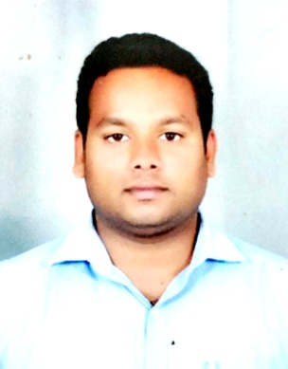
SANDEEP
BUR DUBAI
DUBAI
E: sandeep.384518@2freemail.com
Visa: On Visit

OBJECTIVE
To work in a position where I will increase gains in profit performance, revenue growth and market share by using my expertise and skills in sales management and marketing drive.

PROFILE SUMMARY
Qualified sales representative, have been in the pharmaceutical industry for 7 years and has proven sales experience. Excellent communicator with negotiation and persuasion skills that reliable, driven to succeed. Well versed with sales techniques, developing of market and business oriented strategy.

STRENGTH
- Ambitious and highly motivated to meet the demands of the job
- Excellent skills in marketing and business development
- Experienced in managing sales in various hospital and chemist outlets and renowned brand
- Have a track record of getting results and generating sales and improve the service offered
- Able to identify and develop new business opportunities
- Exceptional communication skills
- Good time management skills
- Able to work under pressure and with no supervision at all
- Skilled in various computer programs in sales and marketing
- Previous experience working in competitive markets and delivering results
- Great troubleshooting and problem-solving skills

EXPERIENCE
Business Executive March 2018- Oct 2018
Eris Life Sciences Pvt Ltd

Business Head May 2017- Feb 2018
Lloyd Health Care Pvt Ltd

Professional Sales Officer April 2013 – April 2017
Macleods Pharmaceuticals Pvt

Business Development Executive June 2011 – March 2013
Panacea Biotech Pvt Ltd

JOB PROFILE
- Represented the company in multi specialty doctors and health care staff
- Communicating any new products to our customers
- Giving effective client demonstrations
- Keeping follow-ups with customer for queries
- Boosting sales in my territory every month
- Successfully launched new brand with top selling brand in my territory
- Increased product portfolio sales by identifying opportunity
- Increased Customer base with business
- Increased Market share month on month
- Handled more than hundred brands with well prepared product mix
- Researching the market on a regular basis for related products
- Liaising with the suppliers in order to make sure that existing orders increase

EDUCATION
Master Business Management
Specialized In Operation Management
Sikkim Manipal Distance University 2013 – 2015

Bachelors of Business Management
Specialized In Marketing Management
University Of Mysore 2008 - 2011

PERSONAL DETAILS
Civil Status : Unmarried
Date Of Birth : 25-05-1990
Nationality : Indian
Languages : English (Speak, Write)
Hindi (Speak, Write)
Kannada (Speak, Write)
Tamil (Speak, Write)

Hobbies : Reading books, Travelling

Date: (SANDEEP)

