CURRICULUM VITAE
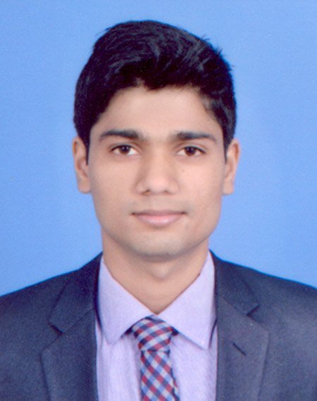
GAJRAJ
Email: gajraj.384606@2freemail.com

OBJECTIVE:
To work in a competitive environment and to give excellent performance in whatever job assigned.

EXPERIENCE:
- Working in Finance Department as a Storekeeper since May 2018.
- Worked in The Avenue, A Murwab Hotel, Doha, Qatar since 23 April 2016 to 26 April 2018 in Finance Department as a Storekeeper.
ACADEMIC PROFILE:
- Master Degree (2013-2015) - M.B.A. from G.L.Bajaj Institute of Management & Research Greater Noida Affiliated to U.P.T.U.
- Bachelor Degree (2009-2012) – B.B.A. from Jhunjhunwala Business School Affiliated to Dr. Ram Manohar Lohia Avadh University.
- Intermediate (2007-2009) –Government Inter College Faizabad.
- High School- (2006-2007)- V.H.S. Faizabad
PERSONAL SKILLS:
- Basic Fire Prevention Techniques.
- Basic knowledge about Chemical Handling.
- Easily adaptable to different work environment.
- Effective Interactive skills with Multi-Racial People.
OTHER ACTIVITIES
- Internship has been done on Marketing Mix plan with Bajaj Automobile for two month, during the perusal of M.B.A
- Internship has been done on Consumer Feedback with Hero Honda Automobiles for two months, during the perusal of B.B.A
ACHIEVEMENTS
- Achieved Star of the Month in February 2017

.
WORKING SKILLS:
- Knows about Micros Opera.
- Knows about Fidelio material control
- Knows that how to organize the goods.
- Knows about the computer system.
- Properly maintain receiving receipts.
- Knows how to maintain Inventory.
- Properly knows about FIFO.
- Sourcing of new suppliers & sampling, testing and approval for new development.
- Proper goods distribution/supply chains maintain and follow up.
COMPUTER SKILLS:
- Windows, Internet, MS office, Excel.

PERSONAL INFORMATION:
Date of Birth : 12 -Dec-1992
Sex : Male
Nationality : Indian
Marital Status : Single
Languages known : English And Hindi
Blood Group : B

